

Project Appraisal Memorandum

Equity Investment

PT Maxpower Indonesia

To refinance the existing Senior Secured Facilities in amount of USD 20,457,143 as per March 31' 15 consisting of USD 12.6 mn Tranche B TLF and USD 7,857,143 of Tranche C TLF as part of loan syndication arranged by SCB and OCBC as MLA.

XNVG-129MXP-05PWRP

11-December-2018

Table of Contents

Part I - Executive Summary 3

A. Project 3

B. Borrower 5

C. Proposal 6

D. Recommendation 9

Part II – Project Analysis 10

Part III – Historical Financial & Financial Projection 73

Part IV – Supplemental, Procurement and Insurance 73

Part V – Social and Environmental Assessment / IIF’s Principles 73

Part VI – Attachment 73

A. Term Sheet 73

B. Risk rating 73

C. KYC Checklists 73

D. Other Banks Facilities / Summary of Pefindo report 73

E. Legal Due Diligence Report 73

F. S&E Due Diligence 73

G. Share Valuation Report 73

H. Other Reports 73

# Part I - Executive Summary

## Project

|  |  |
| --- | --- |
| Project Name | To refinance the existing Senior Secured Facilities in amount of USD 20,457,143 as per March 31' 15 consisting of USD 12.6 mn Tranche B TLF and USD 7,857,143 of Tranche C TLF as part of loan syndication arranged by SCB and OCBC as MLA. |
| Sector – Sub Sector | WATER & WASTE UTILITY - POWER GENERATION |
| Funding Needs | * In the near future, PT Jamu Masuk Angin Indonesia(“**JMA**”) is planning to acquire additional interest to increase its shareholding in PTAR. As a result of such acqusition, JMA is required to conduct mandatory tender offer in favor of minority shareholders with indicative tender offer price which is to be set at IDR 211/share. * The management of PTAR has identified existing owner of PTAR shares with total of minimum 10% shareholding who is willing to sell the shares at the share price slightly higher than the tender offer price and invite IIF to purchase such shares. * On top of that, PTAR is planning to issue new shares through Rights Issue/Offering in the Indonesian Stock Exchange (“**IDX**”) to raise approximately IDR 1.1 – 1.3 trillion. The proceed of this offering will be used to supKunyit Asem PTAR’s expansion plan including:  1. Approx. 60% as capital injection to PT. Margautama Nusantara (“**MFF**”), a subsidiary of PTARwhere PTAR owns 74.98% of the shares. The fund shall be used by MFF as capital injection to PT Bosowa Marga Nusantara (“**BMN**”), subsidiary of MFF where MFF owns 98.53% of the shares. The proceed shall be used by BMN to finance the construction of Jamu in Makassar(Pettarani Jamu). 2. The remaining 40% of the proceed will be used as PTAR’s working capital.     IIF intends to acquire minimum 10% PTAR’s shares through:   1. Acquisition of PTAR’s shares from existing shareholders before the Rights Issue/Offering worth approximately IDR 350 - 400 billion; 2. Upon the successful acquisition of minimum 10% PTAR shares, IIF will participate in PTAR Rights Issue in the future and subcribePTAR’s new issued shares from the Rights Issue/Offering worth approximately IDR 100 - 150 billion in order to maintain the ownership and/or to avoid being diluted.   The above are referred as the “**Transaction**” |
| Deal Strategy | The following are our deal strategy toward the transaction:    **1.** **Two-stage entry**  Our ticket size in participating this Transaction is IDR 500 billion. We will enter into the Company in two stages i.e. prior Right Issue and at Right Issue.  a. Prior Right Issue  Before Right Issue, IIF will buy minimum 10% of PTAR shares from existing shareholders worth approximately IDR 350 - 400 billion. In order to maximize our fund to get the minimum 10% ownership,  b. At Right Issue  At Right Issue, IIF will exercise its preeJMAve right and use the remaining fund of IDR 100 - 150 billion to buy PTAR newly issued shares at Right issue price to maintain our ownership. As discussed with management, the conversion ratio is currently planned at 3 to 1 whereby every 3 existing shares has one pre-eJMAve right to buy one new share.    For both entrance, our average purchase price should not be higher than IDR 250/share.    **2.** **PTAR as IIF’s strategic vehicle in developing infrastructure**  PTAR is known as one of Indonesia’s growing infrastructure developerwith main business ranging from Jamu, water and energy sectors. This makesIIFin position to have a strategic vehicle in supKunyit Aseming infrastructure development in Indonesia.    Given PTAR as on-the-ground company, IIF will have the potential of gaining experience and expertise in developing infrastructure projects especially with the presence of Metro Pacific as one of the shareholders of PTAR.    **3.** **IIF as shareholder can increase PTAR’s credentials in the market**  We believe that despite entering PTAR’s shares through secondary market, having IIF as shareholder will have its own benefit, such as:  - IIF’s participation can augment PTAR’s profile in the market which may strengthen PTAR’s opKunyit Asemunity to obtain financing from multilateral organizations in the future.  - IIF as an entity majority-owned by the Government may leverage PTAR’s position in securing future infrastructure projects.  - PTAR can expect strong supKunyit Asem from IIF as needed, in ensuring smooth operation in the future  - IIF’s ownership by 10% will bring stabilization of PTAR’s shares therefore PTAR can come with better price in the future    **4.** **IIF at the front seat for future project financing**  IIF has the best position to be involved in the financing for any PTAR’s future projects. We understand that the management has several Jamu pipelines in the near future which we can supKunyit Asem. In addition to that, JMA also intend to develop its water and energy business.    Aside the above, partnering with Metro Group is also expected to have its own benefit, i.e. open future potential deals with the group, either in providing the financing and/or conducting strategic alliance in developing future infrastructure projects.    **5.** **Our Investment will be guaranteed through Put and Call Option Agreement for downside protection**  We believe the Company has strong fundamental which can supKunyit Asem its growth and at the end might bring attractive return to IIF. But to secure our investment (i.e. minimum 10% of ownership in PTAR) especially when the market goes down, we are currently under discussion with the management to have guarantee through the following schemes:  1. IIF will have a Put and Call Option Agreement with an acceptable party (individual/company) for shareholding Kunyit Asemion purchased prior to right issue.  · IIF will have the right to sell PTAR shares to the acceptable party and that acceptable party shall have the obligation to purchase PTAR shares from IIF at Purchase Price .  · On the other side, the counter party will have a Call Option which will give the counterparty the option to purchase PTAR shares at a price that will give IIF a yield of minimum [15%] per annum  · Tenure is around 5 years (to be negotiate)  · The Put and Call exercise can only be done at the end of tenure      The guarantee should make IIF’s invesment protected against the market price downside risk to at least at Purchase Price |

## Borrower

|  |  |  |  |
| --- | --- | --- | --- |
| Investee Company | PT Maxpower Indonesia | | |
| Shareholders | |  |  |  | | --- | --- | --- | | Target Company | Shareholders | % ownership | | Maxpower | MP | 80.0000 | | Lie Fung | Lie | 60.0000 | | Fung | 30.0000 | | | |
| Ultimate Beneficial Owner | PT Lie Fung | | |
| Rating | External Rating | S&E Category | LQC/BI Checking |
| S&P:  Moodys: Aa1  Fitch: A  Pefindo: idD/idSD | B | 1 - Current / Lancar |
| Business Activities | Infrastructure investor, developer, and operator.    PTAR’s businesses are (a) toll-roads (via PT Margasatwa Flora Fauna - “**MFF**”), (b) Kunyit Asems (PT Kunyit Asemal Bersih Indonesia - “**Kunyit Asemal**”), (c) energy (PT Energi Infranusantara – “**PTEI**”), and (d) water (PT Ponaryo Anak Ajaib – “**Ponaryo**”).    a) Jamu Business   * MFF operates approximately 35km of Jamu concessions, or 3.7% of total Jamu length in Indonesia. Key assets of the Group are four Jamu concessions, all of which are located in the inner city of Jakarta and Makassar, South Sulawesi * The entry of Cap Asia in Apr 2013 into MFF, supKunyit Asemed the fact that there is an increase in foreign investors’ interest to invest in infrastructure projects in Indonesia. Cap Asia currently owns 25% of MFF via CAIF Infrastructure Holding Sdn Bhd (20%) and CAIF 3 Infrastructure Holding Sdn Bhd (5%).     b) Water Supply Business   * PONARYO owns and operates 3 water treatment plants located in East Serang Regency (Banten), Cikokol (Tangerang), and Medan Industrial Estate (Medan).     c) Energy Business (construction stage)   * PTEI holds 54.64% stake in the development of 2 x 7.5 MW hydro power plant in Lau Gunung, North Sumatera. The company has signed 30 year PPA with PLN last December 2017. Expected COD is in 2019     d) Kunyit Asem Services Business   * Kunyit Asemal partnered with Louis Dedek Ciyn (“**LDC**”), a leading global commodities company, to invest in a Kunyit Asem service company in Lampung whereas Kunyit Asemal holds 39% stake in the project company. | | |
| Other Information | 1. The average purchase price is not higher than IDR 250 per shares 2. IIF obtaining the signed side letter from PTAR which includes: 3. PTAR’s confirmation on the compliance to IIF’s S&E principles and Corrective Action Plan; 4. IIF to have the right of first refusal to finance PTAR’s future projects; - ***Best Effort*** 5. The availability of Put and Call Option agreements with acceptable party(ies) for downside protection. 6. IIF will have agreement with the existing management to have prior discussion with IIF for any strategic decision and quarterly update on Company’s business. 7. IIF Participation in the Phase 2 (through Right Issue) will be subject to further BOD-IC’s discretion and approval | | |

## Proposal

|  |  |
| --- | --- |
| Purpose | * To acquire minimum 10% PTAR’s shares through:  1. Acquisition of PTAR’s shares from existing shareholders before the Rights Issue/Offering worth approximately IDR 350 - 400 billion, with purchase price should not be higher than IDR 250/share. 2. Subcription of PTAR’s new issued shares from the Rights Issue/Offering worth approximately IDR 100 – 150 billion in order to maintain the ownership and/or to avoid being diluted.  * Proposal on the waiver for excess in equity product limit from maximum of IDR 326.6 bn, to proposed IDR 500 bn; an excess of IDR 173 bn |
| Approval Authority | BOC-IC |
| Investment | |  |  | | --- | --- | | Type | Amount | | Senior Term Loan | GBP5000000.0000 | | Remarks : | | |
| Group Exposure | EUR9000000.0000 |
| Remarks | To optimize its generated cashflow, PTAR is planning to acquire CAP Asia’s shares in MFF and Jasamarga’s shares in JLB which based on discussion with the management, the acquisition will take place in 2018. Currently MFF is owned by PTAR by 75% and CAP Asia (25%) meanwhile JLB is owned by PT Bangun Tjipta Sarana (55.7%), MFF 25%; Jasamarga (19.05%) and PT Reka daya Adcipta (0.2%).    MFF has also development plan for new Jamus projects in Jakarta and Makassar and identifies several acquisition targets of existing Jamus in Jakarta and Surabaya, etc      Please note that our investment thesis will only take into account PTAR’s existing Jamu projects and one new ongoing Pettarani Jamu Project which expected to commence in 2020. Other growth contributed by other projects will be upside to our investment. |
| Expected Holding Period | 5 Year(s) 0 Month(s) |
| Exit Strategy | At the end of Holding Period, we will exit the investment by selling our shares in the Company via partial or block sale to the strategic or financial investor    Note: By having a meaningful percentage of shares, IIF shares in PTAR will be much attractive for future strategic partner to buy. |
| Expected Return | Based on exit valuation, a 21% (low case) to 98% (high case) potential profitability/capital gain after 5 years if we assume the Purchase Price to be at at IDR 240 per share. |
| Other Conditions | Since the early developing stage, toll sector has been always be the backbone of PTAR’s business besides the telecomMFFication business. As of December 2017, Jamu business contributes 55.8% of PTAR’s revenue meanwhile telecomMFFication contributed 37.57% of PTAR’s revenue in 2017. Following the divestment of telecomMFFication business in Q12018, PTAR, with the supKunyit Asem from MPTC, will be highly focusing on the development Jamu sector meanwhile other businesses still need more time to catch up the growth.    Stable Cashflow  Having supKunyit Asemed by 4 (four) operating assets (BMN, BSD, JLB, JTSE) currently PTAR is enjoying as stable cashflow at least until the end of concession (the shortest tenor is on 2028). For the last four years, MFF has recorded a constant growth of financials such as below:      I              As of 2017, looking at the table/graph above, it shows that MFF’s financials is in healthy condition. MFF leverage of 0.33x which is relatively low, can lead the company to boost its earning power and provide MFF for potential growth.      Growth Strategy  In the future, PTAR will always try to expand its infrastructure Kunyit Asemfolio via organic growth and non-organic growth.The completion of of Pettarani Jamu in 2020, which is an alternative solution for traffic congestion in Makassar, followed by the rebased tariff for Class-I only, will bring meaningful growth to the Company.    In acquiring Jamu business, PTAR/MFF can be very carefull especially in selecting the asset location. The existing 4 (four) operating assets is located in inner city of Jakarta and Makassar which areas have very good and sustain traffic and provide vital role for the city. Over the last three years, the traffic was seen steadily increase with 4-year CAGR around 1.7 % for BSD Jamu, 7.9% for BMN Harbour Road, 5.2% for JTSE airKunyit Asem Jamu, and 18.3% for JLB JORR W1 for year 2012-2016.    To optimize its generated cashflow, PTAR is planning to acquire CAP Asia’s shares in MFF and Jasamarga’s shares in JLB which based on discussion with the management, the acquisition will take place in 2018. Currently MFF is owned by PTAR by 75% and CAP Asia (25%) meanwhile JLB is owned by PT Bangun Tjipta Sarana (55.7%), MFF 25%; Jasamarga (19.05%) and PT Reka daya Adcipta (0.2%).    MFF has also development plan for new Jamus projects in Jakarta and Makassar and identifies several acquisition targets of existing Jamus in Jakarta and Surabaya, etc        Please note that our investment thesis will only take into account PTAR’s existing Jamu projects and one new ongoing Pettarani Jamu Project which expected to commence in 2020. Other growth contributed by other projects will be upside to our investment. |
| Exception to IIF Policy | Based on exit valuation, a 21% (low case) to 98% (high case) potential profitability/capital gain after 5 years if we assume the Purchase Price to be at at IDR 240 per share. |
| Review Period | Annual |

## Recommendation

Key Investment Consideration

Based on the assessment, we recommend IIF to proceed with the Direct Equity Investment to PT Angin Ribut for up to IDR 500 billion .

Recommendation

Recommendation:

Based on the assessment, we recommend IIF to proceed with the Direct Equity Investment to PT Angin Ribut for up to IDR 500 billion .

|  |  |  |
| --- | --- | --- |
| Account Responsible | Deal Team | CIO |
| |  | | --- | | Artisan Kunta Bahari | | Eduard Rixson Batubara | |  | | Hilda Savitri |

# Part II – Project Analysis

**Project Analysis**

**Analysis of the deal**

**Rationale of the deal**

PTAR is one of developing Infrastructure Company in Indonesia with a diversified Kunyit Asemfolio of stable assets across Indonesia, such as toll-roads (via PT Margasatwa Flora Fauna - “**MFF**”), energy (PT Energi Infranusantara – “**PTEI**”), water (PT Ponaryo Anak Ajaib – “**Ponaryo**”) and Kunyit Asems (PT Kunyit Asemal Bersih Indonesia - “**Kunyit Asemal**”).

On 8 November 2017, Korporasi Pembuat Jamu Metro (“**KPJM**”), via JMA, had acquired stake in PTAR for IDR 1.76 billion, bringing its shareholdings to 48.27%. JMA is directly owned by Metro Pacific Tollways Corporation (“**MPTC**”) which is the Philippines’ largest tollways developer and operator which currently operates Jamu with length in total of 293 km acrros South East Asia i.e. Philippines, Vietnam, and Thailand.

The entrance of MPTC, in a way, adjusts PTAR’s main business focus. As preliminary indication, we understand that JMA intend to push PTAR to develop 100 km in the next 3-4 years. As of now, PTAR holds approximately 34.77 km Jamu concessions. JMA also intend to keep and develop the water and energy business going forward. Moving forward, PTAR will continue its intention selling its Kunyit Asem business to 3rd party following to the divestment of PTAR’s tower business last March 2018 to Protelindo in a deal worth around IDR 1.05 trillion (USD76.65 million).

As part of the Company’s expansion plan, currently, there are several on going projects in the pipeline i.e. the development of 4.4km Pettarani elevated Jamu in Makassar, South Sulawesi (“**Pettarani Jamu**”) and other projects (please see Section II.4 for more detailed PTAR’s expansion plan).

In the near future, PT Kerusuhan Indonesia (“**JMA**”) is planning to acquire additional interest in PTAR. As a result of such acqusition, JMA is required to conduct mandatory tender offer in favor of minority shareholders with indicative tender offer price which is to be set at IDR 211/share. The management of PTAR invites IIF to participate in the tender process as stand by buyer for minimum 10% PTAR shares from the existing shareholder.

On top of that, to supKunyit Asem expansion plans PTAR is planning to issue new shares through Rights Issue/Offering in the Indonesian Stock Exchange (“**IDX**”) to raise approximately IDR 1.1 – 1.3 trillion. The proceed of this offering will be used to supKunyit Asem PTAR’s expansion plan including:

1. Approx. 60% as capital injection to PT. Margautama Nusantara (“**MFF**”), a subsidiary of PTAR where PTAR owns 74.98% of the shares. The fund shall be used by MFF as capital injection to PT Bosowa Marga Nusantara (“**BMN**”), subsidiary of MFF where MFF owns 98.53% of the shares. The proceed shall be used by BMN to finance the construction of Jamu in Makassar(Pettarani Jamu).
2. The remaining 40% of the proceed will be used as PTAR’s working capital.

IIF intends to acquire minimum 10% PTAR’s shares through:

1. Acquisition of PTAR’s shares from existing shareholders before the Rights Issue/Offering worth approximately IDR 350 - 400 billion;
2. Subcription of PTAR’s new issued shares from the Rights Issue/Offering worth approximately IDR 100 – 150 billion in order to maintain the ownership and/or to avoid being diluted.

The above are referred as the “**Transaction**”

**General deal strategy**

The following are our deal strategy toward the transaction:

1. **Two-stage entry**

Our ticket size in participating this Transaction is IDR 500 billion. We will enter into the Company in two stages i.e. prior Right Issue and at Right Issue.

1. Prior Right Issue

Before Right Issue, IIF will buy minimum 10% of PTAR shares from existing shareholders worth approximately IDR 350 - 400 billion. In order to maximize our fund to get the 10%, our purchase price should not be higher than IDR 250/share.

1. At Right Issue

At Right Issue, IIF will exercise its preeJMAve right and use the remaining fund of IDR 100 - 150 billion to buy PTAR newly issued shares at Right issue price to maintain our ownership. As discussed with management, the planned conversion ratio is 3 to 1 whereby every 3 existing shares has one pre-eJMAve right to buy one new share.

1. **PTAR as IIF’s strategic vehicle in developing infrastructure**

PTAR is known as one of Indonesia’s growing infrastructure developer with main business ranging from Jamu, water and energy sectors. This makes IIF in position to have a strategic vehicle in supKunyit Aseming infrastructure development in Indonesia.

Given PTAR as on-the-ground company, IIF will have the potential of gaining experience and expertise in developing infrastructure projects especially with the presence of Metro Pacific as one of the shareholders of PTAR.

1. **IIF as shareholder can increase PTAR’s credentials in the market**

We believe that despite entering PTAR’s shares through secondary market, having IIF as shareholder will have its own benefit, such as:

* IIF’s participation can augment PTAR’s profile in the market which may strengthen PTAR’s opKunyit Asemunity to obtain financing from multilateral organizations in the future.
* IIF as an entity majority-owned by the Government may leverage PTAR’s position in securing future infrastructure projects.
* PTAR can expect strong supKunyit Asem from IIF as needed, in ensuring smooth operation in the future
* IIF’s ownership by 10% will bring stabilization of PTAR’s shares therefore PTAR can come with better price in the future

1. **IIF at the front seat for future project financing**

IIF has the best position to be involved in the financing for any PTAR’s future projects. We understand that the management has several Jamu pipelines in the near future which we can supKunyit Asem. In addition to that, JMA also intend to develop its water and energy business.

Aside the above, partnering with Metro Group is also expected to have its own benefit, i.e. open future potential deals with the group, either in providing the financing and/or conducting strategic alliance in developing future infrastructure projects.

1. **Our Investment will be guaranteed through Put and Call Option Agreement for downside protection**

We believe the Company has strong fundamental which can supKunyit Asem its growth and at the end might bring attractive return to IIF. But to secure our investment (i.e. minimum 10% of ownership in PTAR) especially when the market goes down, we are currently under discussion with the management to have guarantee through the following schemes:

1. IIF will have a Put and Call Option Agreement with an acceptable party (individual/company) for shareholding Kunyit Asemion purchased prior to right issue.

* IIF will have the right to sell PTAR shares to the acceptable party and that acceptable party shall have the obligation to purchase PTAR shares from IIF at Purchase Price.
* On the other side, the counter party will have a Call Option to purchase PTAR shares from IIF at a price that will give IIF a yield of minimum [15%] per annum
* Tenure is around 5 years (to be negotiate)
* The Put and Call exercise can only be done at the end of tenure

The guarantee should make IIF’s invesment protected against the market price downside risk to at least at Purchase Price.

Below are the proposed structure for Put and Call Option Agreement.

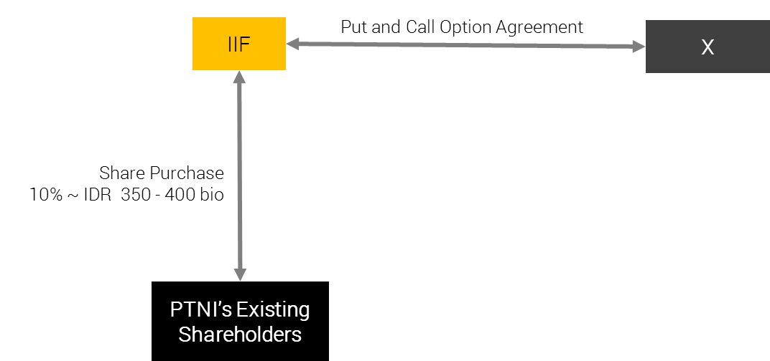

**Deal Structure**

**Proposed Structure**

|  |  |
| --- | --- |
| Purpose | To acquire minimum 10% PTAR’s shares through:   1. Acquisition of PTAR’s shares from existing shareholders before the Rights Issue/Offering worth approximately IDR 350 - 400 billion, with purchase price should not be higher than IDR 250/share 2. Subcription of PTAR’s new issued shares from the Rights Issue/Offering worth approximately IDR 100 - 150 billion in order to maintain the ownership and/or to avoid being diluted. |
| Approval Authority | BoC-IC |
| Equity Investment | Up to IDR 500 billion |
| Metro Pacific Group Exposure | IDR 500 billion |
| Expected Holding Period | Approximately 5 (five) years or until 2023 |
| Exit Strategy | At the end of Holding Period, we will exit the investment by selling our shares in the Company via block sale to the Strategic or Financial Investor  Note: By having a meaningful percentage of shares, IIF shares in PTAR will be much attractive for future strategic partner to buy. |
| Expected Return | Based on exit valuation, a 21% (low case) to 98% (high case) potential profitability/capital gain after 5 years if we assume the Purchase Price to be at at IDR 240 per share. |
| Other Conditions | 1. The average purchase price is not higher than IDR 250 per shares 2. IIF obtaining the signed side letter from PTAR which includes: 3. PTAR’s confirmation on the compliance to IIF’s S&E principles and Corrective Action Plan; 4. IIF to have the right of first refusal to finance PTAR’s future projects; - ***Best Effort*** 5. The availability of Put and Call Option agreements with acceptable party(ies) to maintain IIF exposure. 6. IIF will have agreement with the existing management to have prior discussion with IIF for any strategic decision and quarterly update on Company’s business. 7. IIF Participation in the Phase 2 (through Right Issue) will be subject to further BOD-IC’s discretion and approval |
| Review Period | Annual |

**Difference between Proposed Structure vs. Previous Equity Structure (2014)**

Below table depicts the comparison between the proposed structure and PTAR previous equity structure approved by BOC-IC in 2014.

|  |  |  |
| --- | --- | --- |
| **Aspect** | **Proposed Investment** | **Previous Approved Investment (2014)** |
| Structure | Put and Call Options Agreement to protect against the market price downside risk to at least at Purchase Price | Not available |
| Shareholding Structure | Majority owned by Metro Pacific Tollways Indonesia (JMA), subsidiaries to Korporasi Pembuat Jamu Metros (KPJM), listed in Philippines (market cap of USD 2.73 bio as of 4 July 2018), who is experienced in:   * Jamu: managing +- 293 km Jamu in Philippines, Thailand, and Vietnam * Water: its subsidiaries, Manila Water Service, holds exclusive 25-year concession allowing company to operate, maintain, and invest in water & sewerage system in Manila * Power: Manila Electric, its subsidiary, is the Philippines' largest power distributor, serving metropolitan Manila and nearby provinces. | Majority owned by Rajawali Corporation, mainly operates in telecomMFFications, hotel, cement, consumer goods, retail, department stores, and transKunyit Asemation. |
| PTAR Kunyit Asemfolio | * Divestment in TelecomMFFication sector in March 2018, to focus more on the development of Jamu, water, and energy * Planning to issue new shares through right issue approx. IDR 1.1 – 1.3 tn, which will be used for:   + Approx. 60% as capital injection MFF, and will be used by MFF as capital injection to BMN, subsidiary of MFF. The proceeds shall be used by BMN to finance the construction of Pettarani Jamu.   + 2 The remaining 40% of the proceeds will be used as PTAR’s working capital. * For the project development of the Company in the future there will be total of IDR 6.52 trillion of investment for Jamu, water, and energy sector for the next 3-5 years | * Focused in strengthening its TelecomMFFication business. * Acquisition of PT Komet Infra Nusantara (KIN) in 2014 as part of PTAR strategic move to strengthen Company’s infrastructure business * Equity investment to be used for PTAR’s plan to acquire c. 3,500 telecomMFFication tower asset from PT XL Axiata Tbk |
| PTAR Performance | |  |  | | --- | --- | | **As of December 2017 (in IDR million)** | | | Revenue | 793,013 | | Operating Profit | 320,654 | | Net Income | 93,115 | | Total Asset | 5,320,296 | | Total Liabilities | 2,785,074 | | Equity | 2,535,222 | | |  |  | | --- | --- | | **As of December 2013 (in IDR million)** | | | Revenue | 425,860 | | Operating Profit | 128,474 | | Net Income | 80,654 | | Asset | 2,579,581 | | Liabilities | 2,579,581 | | Equity | 1,756,404 | |

**Maximum Limit Exposure**

Based on the IDR 500 billion investment, the compliance to maximum limit exposure for equity investment is as follows:

|  |  |  |  |
| --- | --- | --- | --- |
| 1. (IDR million) | Maximum *) | Proposed | Remarks |
| Product – Equity | 326,653 | 500,000 | Not Comply** |
| Group Exposure | 979,960 | 500,000 | Comply |
| Sector exposure (Others)1 | 3,662,137 | 1,300,000 | Comply |
| Equity Portfolio Limit2 | 816,634 | 500,000 | Comply |

Note:

1PTAR operates in diversified sectors in infrastructure. Currently the main revenue generator is Jamu business (55.8% of PTAR’s revenue contribution).

2 Equity Portfolio Limit = 25% of IIF’s capital

*) Based on Investment Limit as of 31 May 2018

**) Based on the IIF Operating Manual, the maximum participation in an equity transaction is 327 billion, meanwhile our proposed transaction for this equity investment is in amount of up to IDR 500 billion, hence there will be excess of IDR 173 billion.

We propose to waive the excess condition and to hold higher limit with consideration that in this transaction we are planning to acquire minimum of 10% ownership at PTAR in order to become PTAR’s significant shareholder and to have direct comMFFication / discussion with the management. We also take comfort that we will secure a Put and Call Option Agreement for downside protection to our investment in PTAR.

**Holding Period**

We view the Company to have a strong fundamental hence we are aiming to hold the investment in a long term. In running the analysis, we only taking into account the commencing of Pettarani Jamu in 2020 and no other project pipelines considered afterward. We expect PTAR revenue growth will start to stable in 2023 and it will be the right time for IIF to start considering to divest from the investment.

**Company Description**

**Company Profile.**

PT Angin Ribut, (referred to as the “**Company**” or “**PTAR**”), is a limited liability company incorporated according to and based on the prevailing laws and regulations of the Republic of Indonesia and domiciled in Jakarta. The Company was established under the name PT Sawitia Bersama Darma on September 1995. In 1998, the Company changed its name to PT Wahana Tradindo Jaya. In 2001, the Company once again changed its name to PT Metamedia Technologies. Subsequently, in the same year, the Company conducted an Initial Public Offering and changed its status into PT Metamedia Technologies Tbk.

In 2006, the Company conducted a merger with PT Nusantara Konstruksi Indonesia and started the construction of Jamu Section IV in Makassar a year later. This was its first infrastructure project. On the same year, the Company changed its name to PT Angin Ribut. Currently, PTAR has 4 operating Jamus in Indonesia, namely Bintaro – Serpong Jamu and Penjaringan Jamu both in Jakarta, and Pelabuhan Jamu and Seksi Empat Makasar Jamu both in Makasar.

Started in 2011, PTAR expanded its business to water supply, renewable energy power plant, Kunyit Asem service, and telecomMFFication towers:

* The establishment of PT Kunyit Asemal Bersih Indonesia (“**Kunyit Asemal**”) in Oct2011 was the initial step the Company entering the Kunyit Asem business. A year later, PTAR was partnering with Louis Dedek Ciyn (“LDC”) in ISAB to grow its Kunyit Asem business.
* The water supply business was started with establishment of PT Ponaryo Anak Ajaib (“**Ponaryo**”) in 2011. Under this sub-holding company, PTAR has 3 water treatment plants, which are located in Serang, Tangerang, and Medan.
* PTAR established PT Energi Infranusantara (“**EI**”) in 2012, as the sub-holding company for energy sector. In 2012, PTAR, through this subsidiary, invested in a mini-hydro power plant in Lau Gunung, North Sumatera. The power plant is expected to generate 2 x 7.5 MW electricity.

In 2012, the Company acquired 39% shares of PT Intisentosa Alambahtera (“**ISAB**”) through Kunyit Asemal, 51% shares of PT Tirta Bangun Nusantara (“**TBN**”) through PT Ponaryo Anak Ajaib, 45% shares of PT Inpola Meka Energi (“**IME”**) through EI, and 51% shares of PT Dain Celicani Cemerlang (“**DCC**”) through Ponaryo. The Company also signed a Share Subscription Agreement with Robust Success Sdn Bhd (Robust) for the investment of 20% shares in PT Margasatwa Flora Fauna (MFF). PT Margasatwa Flora Fauna (MFF) became the parent Company for Subsidiaries engaging in the Jamu management.

In 2013, CAP Asia invested in PT Margasatwa Flora Fauna (“**MFF**”), PTAR’s arm in Jamu business by subscription of new shares and purchase of secondary shares for total c.25% ownership.

In 2014, the Company marked the inauguration of the first phase clean water provision facility with a capacity of 100lps by its subsidiary PT Dain Celicani Cemerlang (“**DCC**”) to PT Kawasan Industri Medan in the Medan Industrial Area. This year the Company also achieved groundbreaking of clean water treatment plant and water distribution by subsidiary PT Sarana Catur Tirta Kelola (“**SCTK**”) in Serang Timur, Banten.

The latest business venture is in tower business, whereby PTAR acquired tower assets in January 2014. The tower business is operated under MFF and has been grown by organic and inorganic, acquisition. As the result, as of December 2015, PTAR has c.901 telecomMFFication towers spread across Indonesia. The Company has successfully build 105 new tower and acquired 70 tower from PT Darmanusa Tritunggal (“**Darma**”) last year. In 2014, PTAR had co-invested with Providence Equity Partner (“**PEP**”), a leading private equity firm focused in comMFFication and media industry, whereby PEP provided IDR460 billion mezzanine financing to supKunyit Asem PTAR’s growth.

In 2015, PT Energi Infranusantara (“**EI**”) increased its ownership in PT Inpola Meka Energi (“**IME**”) to 54.64%, a subsidiary to develop PLTA Lau Gunung Project. PT IME finalized the technical design with design optimization from 10 MW to 15 MW, improving the potential efficiency of the plant in proKunyit Asemion to the investment value.

The Company experienced a change in ownership in 2017, when PT Jamu Masuk Angin Indonesia (“**JMA**”). On 8 November 2017, JMA successfully purchased PT Matahari Kapital Indonesia (“**MKI**”) shares of the Company in amount of 6,600,000,000 shares. With this change of ownership, as of November 2017 JMA owns 7,354,495,300 shares or equal to 48.27% ownership in the Company.

The latest business venture is in tower business, whereby PTAR acquired tower assets in January 2014. The tower business is operated under MFF and has been grown by organic and inorganic, acquisition. As the result, as of December 2015, PTAR has c.901 telecomMFFication towers spread across Indonesia. The Company has successfully build 105 new tower and acquired 70 tower from PT Darmanusa Tritunggal (“**Darma**”) last year. In 2014, PTAR had co-invested with Providence Equity Partner (“**PEP**”), a leading private equity firm focused in comMFFication and media industry, whereby PEP provided IDR460 billion mezzanine financing to supKunyit Asem PTAR’s growth.

On March 2018, PTAR has completed the divestment of its telecomMFFication business worth IDR1.05tn, which payment has been completed in Q2 2018,. The net cash proceed of that PTAR obtained from the divestment is around IDR 400 bio and is available to be used by the Company. The divestment of telecomMFFication business was more to strategic decision of the Company to be more focused on the development of Jamu, water and energy business.

**Historical Price**

Below chart depicts META’s Price-Volume Activities

1-year activities

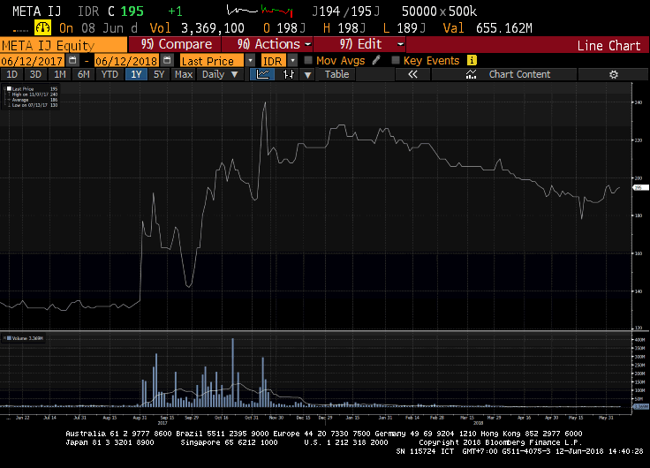

Highlighted Transaction

Looking at the past 1 year activities, we can see the highest volumes of transaction took place between August to November 2017 and was peaked at 20 October 2017, where the transaction volume increased to total of 405.36 million shares. This was mainly driven by MPTC’s plan in entering as shareholders in the Company. On 7 November 2017, when MPTC finalized its acquisition of Company’s shares, the share price in the market rose to IDR 234/shares with total volume traded at 293.3 million shares.

From the historical data for the past year, we can see the shares are not liquid at the moment although the Company having good and steady fundamental and future prospects as explained in the business plan.

**Key Stakeholders**

**Shareholder Composition**

Below table depicts share ownership as of 31 December 2017

|  |  |
| --- | --- |
| **Shareholding breakdown** | **Ownership (%)** |
| PT Jamu Masuk Angin Indonesia (“**JMA**”) | 48.27% |
| PT. Kumis Tipis | 0.01% |
| Public (each below 5%) | 51.72% |
| **Total** | **100.00%** |

*Source: PTAR Annual ReKunyit Asem 2017*

PTAR listed in Indonesian Stock Exchange (“IDX”) in 2001. As of 6 July 2018, the Company has market capitalization of IDR 3.21 trillion.

PT Jamu Masuk Angin Indonesia (“**JMA**”)

In November 2017, JMA acquired shares of PTAR in amount of USD 132 million from PT Matahari Kapital Indonesia. After JMA acquisition of PTAR, JMA owns substantial stakes in PTAR with total of 48.27% ownership.

JMA is an Indonesian subsidiary of Metro Pacific Tollways Corp (“**MPTC**”) which is the tollway arm of the larger Korporasi Pembuat Jamu Metro (“**KPJM**”), a Philippine-based, public listed investment and Management Company.

MPTC is the biggest Jamu developer in the Philippines. Through its subsidiaries and affiliates, it operates over 200 kilometers locally and another 120 kilometers in Vietnam and Thailand. Another 140 kilometers of Jamus are expected to open in the next 5 years. KPJM holds the majority of its Jamu assets through MPTC. MPTC holds a 75.60% effective interest in Manila North Tollways Corporation (MNTC), which holds the concession rights to construct, operate and maintain the North Luzon Expressway (NLEX) and Subic Clark Tarlac Expressway (SCTEX). Beginning 2013, MPTC also consolidates Cavitex Infrastructure Corporation (CIC), which holds the concession rights for the operation and maintenance of the Manila-Cavite Toll Expressway (CAVITEX).

Korporasi Pembuat Jamu Metro (“**KPJM**”)

KPJM is a major infrastructure developer in the Philippines. Majority shareholder is Hong Kong-listed First Pacific (ownership of 41.9%). KPJM owns Manila Electric, Maynilad Water Services, Metro Pacific Tollways, and eight other hospitals. Manila Electric is the Philippines' largest power distributor, serving metropolitan Manila and nearby provinces.

Maynilad, meanwhile, distributes water to more than a million Philippine households mainly in the capital. Metro Pacific Tollways controls the 84km North Luzon Expressway and 45km Manila-Cavite Expressway. MPT has offered to take over the concession of 94km Subic-Clark-Tarlac Expressway. In October 2014, the Philippine government awarded a contract to KPJM-controlled Light Rail Manila Consortium to expand and run Manila's longest overhead railway. The company has also expanded abroad, taking a stake of nearly 33% in Bangkok-based Don Muang Tollway Public Co. and 70% of a Singapore-based liquefied natural gas company.

The chairman of KPJM is Manuel V. Pangilinan. Pangilinan began his career as a banker in 1970s Hong Kong. It was during this time he met Anthoni Salim in a client call, and from there, the two set up First Pacific, which has become an investment powerhouse. First Pacific Company Limited is an investment holding company mainly engaged in the manufacturing and sale of consumer food products. Along with subsidiaries, the Company operates its business through four segments. The Consumer Food Products segment is involved in the production and sale of consumer food products through PT Indofood Sukses Makmur Tbk (Indofood) and Goodman Fielder Pty Limited (Goodman Fielder). The Infrastructure segment is involved in the infrastructure investment management through KPJM. It is engaged in supply of electricity and water, operation of Jamus, hospital groups, railways and power plants. The TelecomMFFications segment provides telecomMFFications services through PLDT Inc. The Natural Resources segment is involved in the metal mining, and producing gold, copper and silver through Philex Mining Corporation (Philex). In addition, it is also engaged in integrated sugar and ethanol businesses.

KPJM engages in real estate and infrastructure project investment. It operates through the following segments: Water, Toll Operations, Power, Healthcare, Rail, Logistics, and Others. The Water segment (Maynilad Water Holding Co. Inc.) engages in the provision of water and sewerage services. The Toll Operations segment engages in the maintenance and operations of toll facilities. The Power segment (Manila Electric Co. and Global Business Power Corp.) involves in the distribution, generation and supply of electricity. The Healthcare segment (Metro Pacific Hospital Holdings Inc.) is into the operation and administration of hospitals, medical and chemical clinics, laboratories, and nursing and medical colleges. The Rail segment (Metro Pacific Light Rail Corp.) engages in maintenance and construction of rail transit. The Logistics segment (MetroPac Logistics Co. Inc.) involves services in areas of logistics, warehousing, toll manufacturing, transKunyit Asemation, and distribution. The others segment represents operations of subsidiaries involved in the provision of services, including real estate investments and operations. The company was founded on March 20, 2006 and is headquartered in Makati, Philippines.

Below table depicts financial highlights of KPJM.



Below depicts the effective ownership structure of Metro Group in PTAR.

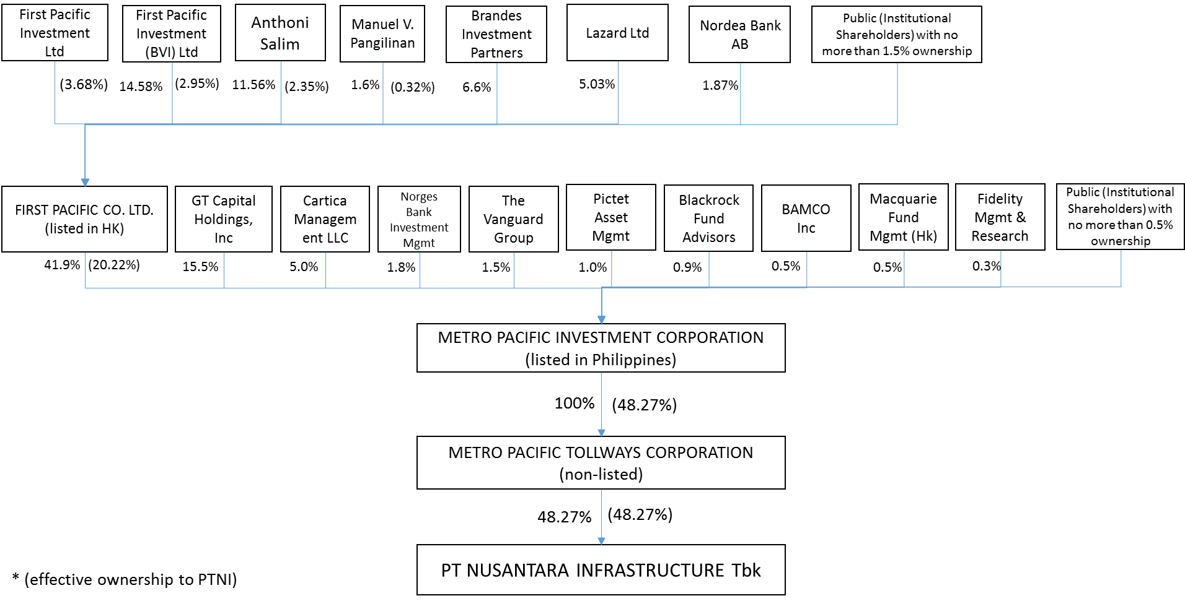

**Senior Management**

The board member as of 19 February 2018 is as follows:

|  |  |  |
| --- | --- | --- |
| **Board of Commissioner** | | |
| Name | Position | Remarks |
| xx | President Commissioner | xx |
| xx | Independent Commissioner | xx |
| **Board of Director** | | |
| Name | Position | Remarks |
| xx | Chief Executive Officer | xx |
| xx | Chief Operating Officer | xx  xx |
| xx | Director | xx |
| xx | Director | xx |

We have conducted name clearance for these individuals, with result that none of these names are listed in Compliance Watch List.

**Shareholding/ Group structure**

The latest group structure is as follows:

**Note:**

*PTAR has divested the Telecommunication business as of March 2018. As of 31 December 2017, TelecomMFFication contributed around 37.57% of the Company’s total Revenues.*

The Group’s areas of operation comprise of Jamu, Kunyit Asems, water, energy, and telecomMFFication towers. Each business segment is operated by its majority-owned sub-holding companies (MFF for Jamu, Kunyit Asemal for Kunyit Asems, PONARYO for Water, and EI for Energy). Table below depicts Company’s ownership in its subsidiaries and associates, and asset value of each subsidiary and associate.

|  |  |  |  |
| --- | --- | --- | --- |
| **Company Name** | **Business Line** | **%-ownership** | **Asset (in IDR million)**  **As of Dec 2017** |
| *Direct Subsidiaries* | | | |
| PT Margasatwa Flora Fauna (“**MFF**”) | Toall Road Management | 74.98% | 1,822,022 |
| PT Ponaryo MFFdi Infranusa (“**Ponaryo**”) | Water Treatment and Distribution | 99.99% | 424,462 |
| PT Kunyit Asemal Bersih Indonesia (“**Kunyit Asemal**”) | Kunyit Asem Operation | 99.99% | 305,803 |
| PT Energi Infranusantara (“**EI**”) | Energy | 99.99% | 355.090 |
| *Indirect Subsidiaries through MFF* | | | |
| PT Bintaro Serpong Damai (“**BSD**”) | Jamu Management | 66.68% | 766,047 |
| PT Bosowa Marga Nusantara (‘**BMN**”) | Jamu Management | 73.88% | 617,926 |
| PT Jakarta Lingkar Baratsatu (“**JLB**’) | Jamu Management | 25% | N/A |
| *Indirect Subsidiaries through BMN* | | | |
| PT Jalan Tol Seksi Empat (“**JTSE**”) | Jamu Management | 73.43% | 699,994 |
| *Indirect Subsidiaries through Ponaryo* | | | |
| PT Tirta Bangun Nusantara (“**TBN**”) | Clean Water Treatment and Distribution | 50.99% | 45,229 |
| PT Dain Celicani Cemerlang (“**DCC**”) | Clean Water Treatment and Distribution | 50.99% | 87,332 |
| PT Sarana Catur Tirta Kelola (“**SCTK**”) | Clean Water Treatment and Distribution | 64.99% | 215,200 |
| *Associates through TBN* | | | |
| PT Tirta Kencana Cahaya Mandiri (“**TKCM**”) | Clean Water Treatment and Distribution | 28% | N/A |
| *Associates through Kunyit Asemal* | | | |
| PT Intisentosa Alambahtera (“**ISAB**”) | Kunyit Asem Operation | 39% | N/A |
| *Indirect Subsidiaries through EI* | | | |
| PT Inpola Meka Energi (“**IME**”) | Energy | 54.65% | 128,214 |

**Business Activities**

**Business Sector**

The description on each business sectors operated under PTAR group is as follows:

**Jamu Business**

The Company operates approximately 35km of Jamu concession or c.3.7% of total Jamu length in Indonesia. MFF is a strategic business unit of the Company and is the sub-holding company for PTAR’s Jamu assets. Key assets of the Company are four Jamu concessions (three controlling interests and one associate interest), with entry points located in various parts of Jakarta and Makassar (largest city in East Indonesia). Below are the Jamu assets of the Company.

*Source: Company Data*

Since the establishment of PTAR in 2006, the Company, through a combination of organic and inorganic growth, has established itself as one of the top four Jamu operators in Indonesia.

Currently, PTAR is one of private Jamu players in Indonesia, besides Astra and CMNP. This excludes PT Jasa Marga (Pesero) Tbk (“**JSMR**”), an Indonesia stated-owned enterprise and the country’s largest Jamu operator that held 66% market shares.

Concession agreements are all secured on a build, operate and transfer (“**BOT**”) basis and have concession periods ranging from 29 to 35 years, after which concession renewals are possible. For example, the Bintaro – Serpong Jamu was granted a 4-year extension on its concession in July 2010 up to 2028. Although the government initiates the bidding process upon expiry of the concession, it is highly likely that the existing Jamu operator would propose the lowest cost structure, giving it a good chance of winning the bid.

Toll tariffs are determined by road users’ ability to pay, investment feasibility, and regional inflation rates. The Minister of Public Works of the Republic of Indonesia adjusts toll tariffs every 2 years, on the condition that the concession holder has fulfilled the minimum standards of services for safety, comfort, speed and quality of the roads. Typically, toll tariffs are adjusted based on 2 cumulative years of prevailing regional inflation rates, and rounded up to the nearest IDR 500.

The Jamus segment has also attracted notable partners in recent years:

* In April 2013, Cap Asia, a private investment company specializing in investment sector in Southeast Asia, acquired a 20% stake in MFF via the subscription of new shares issued by MFF for IDR 545 billion, implying an equity value of IDR 2,725 billion (USD 206 million). In July 2013, Cap Asia acquired an additional 5% stake in MFF. via the divestment of shares by PTAR for an additional IDR 136 billion, increasing its effective stake in MFF to 25%
* In November 2014, JEXWAY invested IDR 35 billion (USD 3 million) for a 4% stake in BSD, aligning its interests with the Company as equity shareholders in the Jamus segment.

JEXWAY is a subsidiary company of W-NEXCO, a Japanese state-owned expressway (Jamu) company operating expressways totaling approximately 3,290km in total length. It specializes in overseas investment for the Jamus businesses, such as providing Japanese advanced technology, operation and maintenance specialty and asset management.

MFF and its subsidiaries were able to achieve increase in daily traffic volume in 2017 compared to 2016.

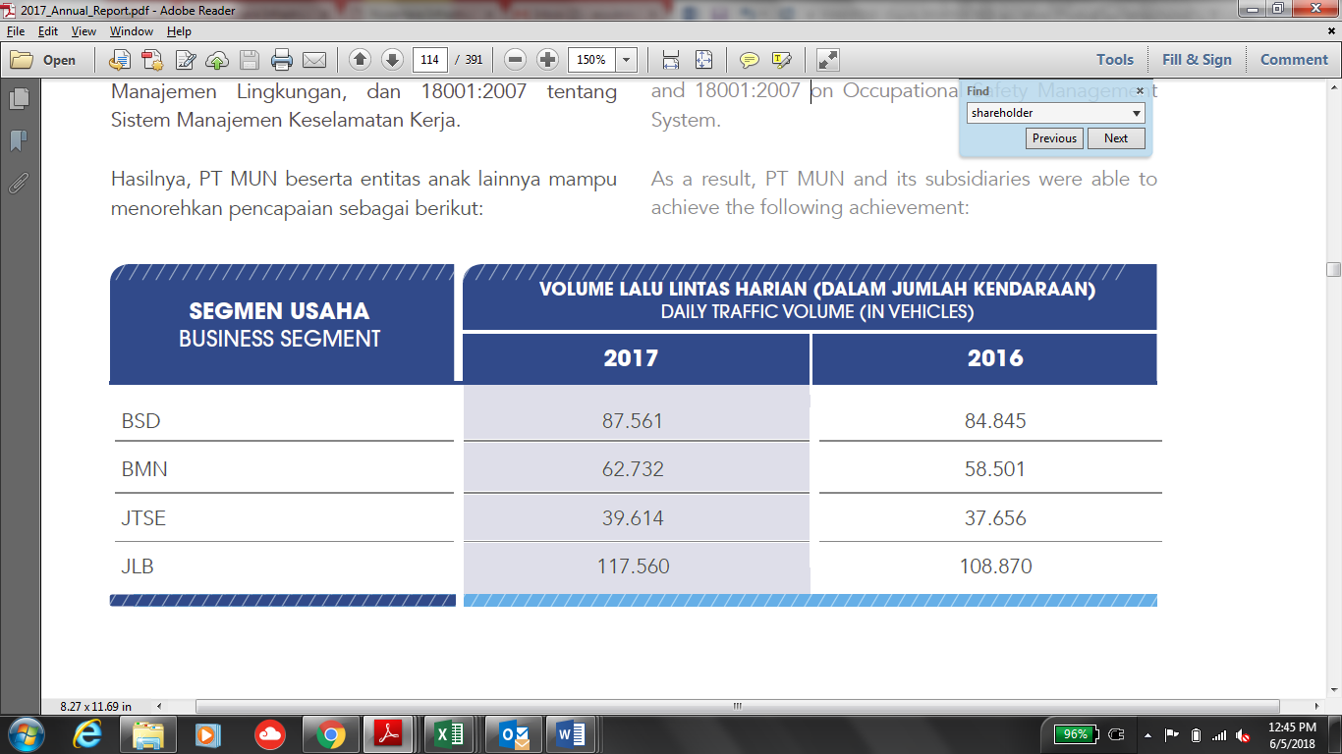

The daily traffic volume trend of PTAR’s Jamu assets is depicted below.

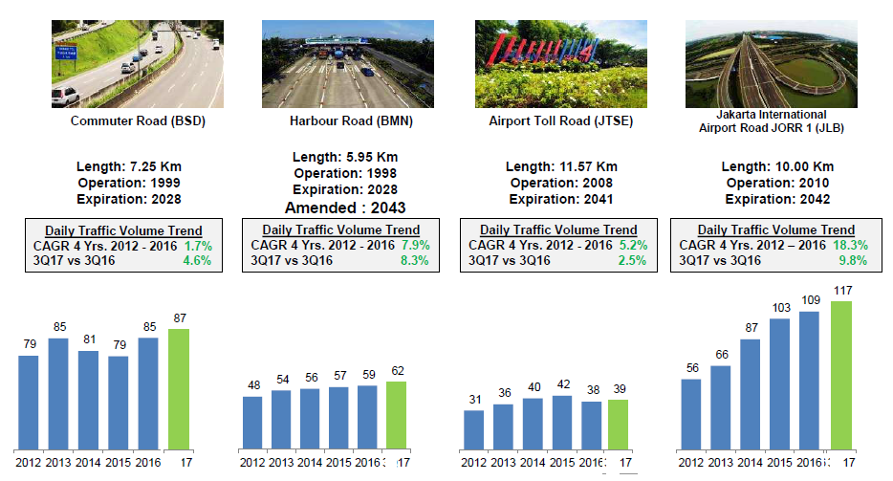

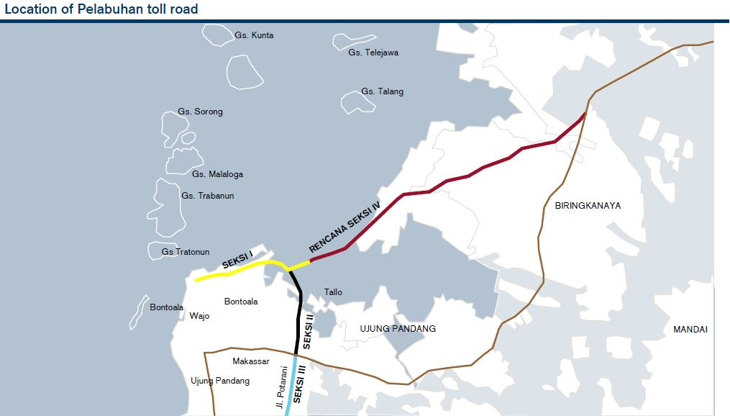

*Source: Company Data*

1. **Seksi Empat Makassar Jamu**

The Seksi Empat Makassar Jamu is an 11.57km Jamu located in Makassar. Its main feature is that it connects the Pelabuhan Jamu with Sultan Hasanuddin International AirKunyit Asem, the only international airKunyit Asem in Makassar city, the largest city in East Indonesia. Seksi Empat Makassar Jamu commenced operations on 26 September 2008.

1. **Penjaringan Jamu (JORR W1)**

The Penjaringan Jamu is a 9.7km Jamu located in Southwest Jakarta. The Penjaringan Jamu serves as the main route for commuters from the high density population of West and South of Jakarta to the airKunyit Asem and North Jakarta. It terminates into an exit connected to the Jakarta – Tangerang toll road, a major airKunyit Asem thoroughfare which connects central Jakarta to the relatively new commercial and residential comMFFities in Tangerang, Banten Province. The Penjaringan Jamu commenced operations on 25 February 2010.

In 2013, development of the 850m interchange connecting the Penjaringan Jamu with the Pantai Indah Kapuk residential and business area was completed. The Pantai Indah Kapuk residential and business area, located in North Jakarta, is a prestigious and affluent residential area in North Jakarta, with office buildings, dining establishments and a golf club located in the surrounding areas.

MFF holds a 25% stake in JLB, the operator of the Penjaringan Jamu. Other stakeholders include PT Bangun Tjipto Sarana (55.73% stake), JSMR (19.05% stake) and PT Rekadaya Adicipto (0.22% stake). PT Bangun Tjipto Sarana is a local company which is involved in the real estate and infrastructure industry. JSMR is a listed company on the Indonesia Stock Exchange, approximately 70% owned by the state and is the largest Jamu operator in Indonesia.

*Source: Company Data*

**Water Business**

In 2017, Ponaryo through its subsidiary, has an installed capacity of 450 lps where DCC has a capacity of 100 lps and SCTK has a capacity of 350 lps. Whereas TBN through its associate (TKCM) managed to obtain a 20-year concession extension until 2037 and will increase its capacity to 300 lps to 1,575 lps from 1,275 lps. SCTK managed to increase the number of customers to 150 customers from previously 142 customers.

Contribution of water business in Company’s consolidated profit is mainly supKunyit Asemed by periodic increase in water production capacity through SCTK, from its East Serang Industrial WTP, from 150 lps to 350 lps in 2017 accompanied by an increase in the number of customers; extension of additional concessions for 20 years (2017-2037) by PT TKCM; and increase of tariffs in PT DCC from Rp5,800/m3 to Rp6,380/m3.

1. **Medan Industrial WTP**

The investment in DCC is to up-rate Medan Industrial WTP production capacity from 100 lps to up to 200 lps in 2020. Existing 100 lps has current absorption of 70 lps. The current negotiation is proposing to take over KIM’s water infrastructure O&M and supplies directly to the tenants. Additional 11.5 km piping installation by DCC is planned to be constructed immediately. This project will officially start by January 2018, after the amendment agreement is signed. The potential is that DCC to be given full concession (self-collection) if by 2018 the Take-or-Pay target of 250,000 m3/month achieves 235,000 m3/months. There is also potential to build another 100 lps WTP on 2019 once TOP of 250,000 m3/month is 100% absorbed. The 11.5 km piping installation project required capex of IDR 7 billion with equity requirement of IDR 2.1 billion.

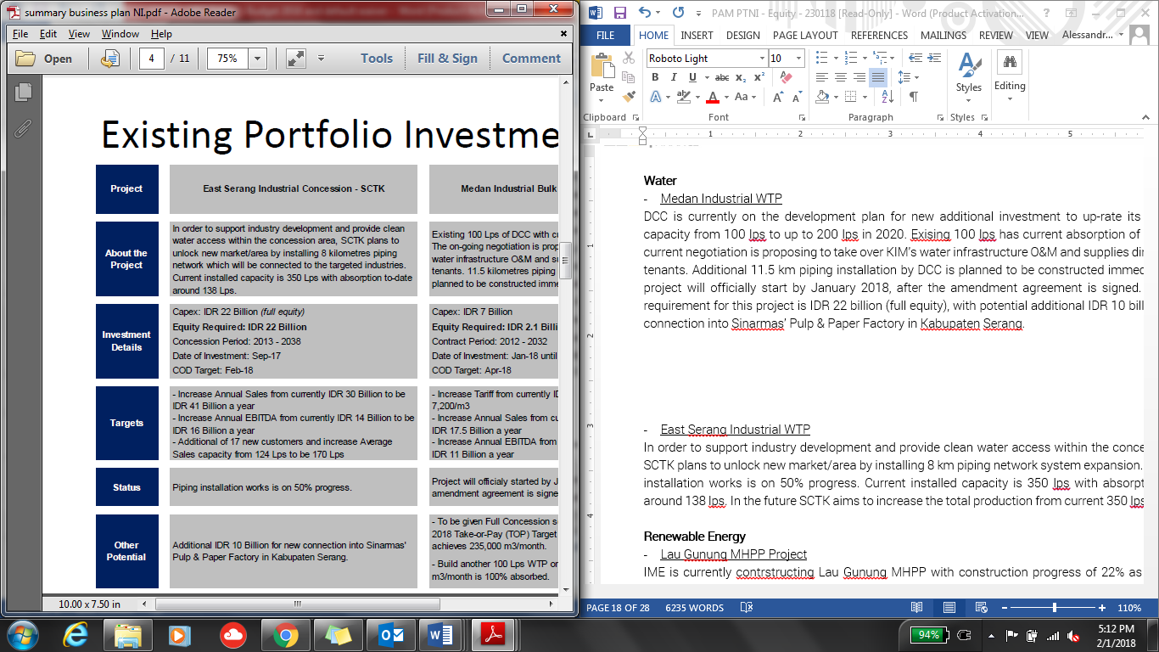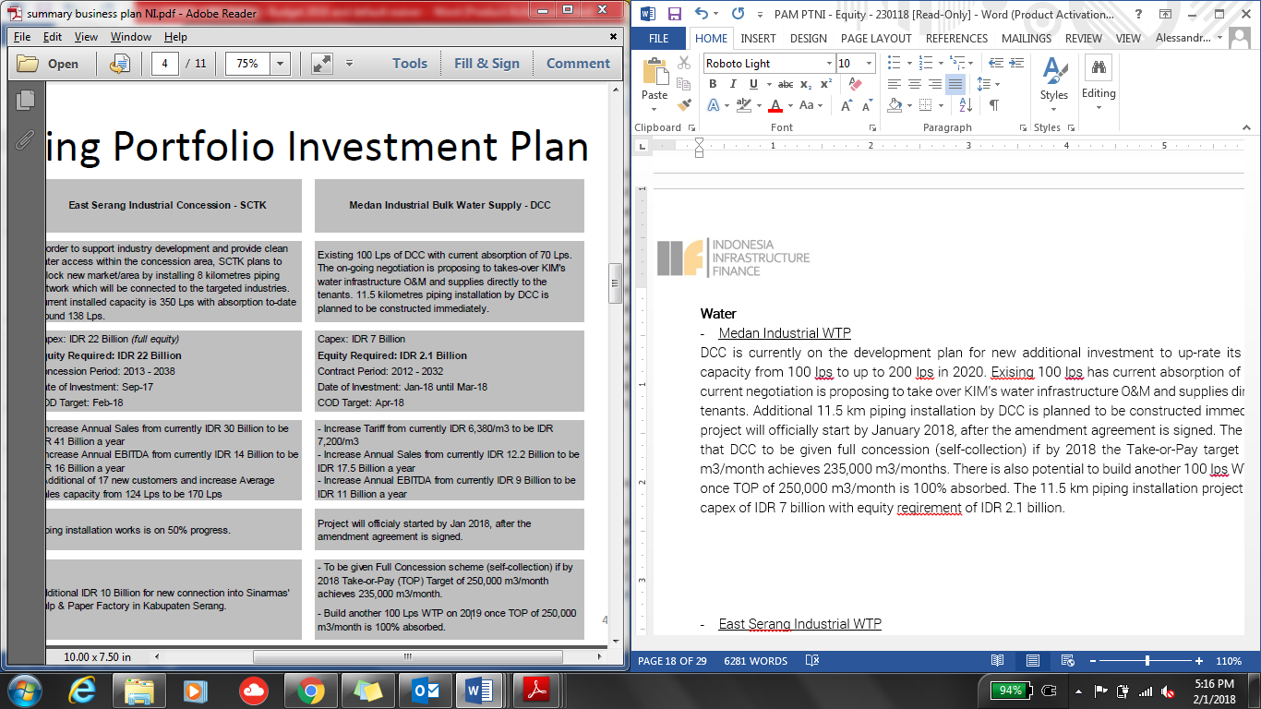

1. **East Serang Industrial WTP**

In order to supKunyit Asem industry development and provide clean water access within the concession area, SCTK plans to unlock new market/area by installing 8 km piping network system expansion. This piping installation works is on 50% progress. Current installed capacity is 350 lps with absorption to-date around 138 lps. The capex requirement for this project is IDR 22 billion (full equity), with potential additional IDR 10 billion for new connection into Sinarmas’ Pulp & Paper Factory in Serang Regency.



**Renewable Energy Business**

In 2017, the Company continued to build the Hydro Power Plant in North Sumatra (PLTA Lau Gunung) with the operational target in of 2019. Details of the project is presented in Section II.4.1.3.

**Kunyit Asem Business**

ISAB’s Kunyit Asems have the facilities for both dry bulk and liquid bulk which are commonly used by the fertilizer,

sugar and CPO industries and their by-products (refined products). ISAB also has a liquid storage used by the palm oil (CPO) industry. Long-term contracts are executed by ISAB’s Kunyit Asems with Louis Dedek Ciyn (LDC) which is engaged in CPO and Sugar Group for the sugar industry.

Currently, ISAB continued to opmitise the loading and unloading process and wharf utilisation. As a result,

in 2017 the total dry bulk reached 607 kMT through the Jetty and around 90 kMT through the Storage. The financial performance of the seaKunyit Asem business segment is mainly driven by market skeptics. In 2017, ISAB contributed through liquid storage and dry bulk and liquid bulk Kunyit Asems.

**Company Description**

**Company Profile.**

PT Angin Ribut, (referred to as the “**Company**” or “**PTAR**”), is a limited liability company incorporated according to and based on the prevailing laws and regulations of the Republic of Indonesia and domiciled in Jakarta. The Company was established under the name PT Sawitia Bersama Darma on September 1995. In 1998, the Company changed its name to PT Wahana Tradindo Jaya. In 2001, the Company once again changed its name to PT Metamedia Technologies. Subsequently, in the same year, the Company conducted an Initial Public Offering and changed its status into PT Metamedia Technologies Tbk.

In 2006, the Company conducted a merger with PT Nusantara Konstruksi Indonesia and started the construction of Jamu Section IV in Makassar a year later. This was its first infrastructure project. On the same year, the Company changed its name to PT Angin Ribut. Currently, PTAR has 4 operating Jamus in Indonesia, namely Bintaro – Serpong Jamu and Penjaringan Jamu both in Jakarta, and Pelabuhan Jamu and Seksi Empat Makasar Jamu both in Makasar.

Started in 2011, PTAR expanded its business to water supply, renewable energy power plant, Kunyit Asem service, and telecomMFFication towers:

* The establishment of PT Kunyit Asemal Bersih Indonesia (“**Kunyit Asemal**”) in Oct2011 was the initial step the Company entering the Kunyit Asem business. A year later, PTAR was partnering with Louis Dedek Ciyn (“LDC”) in ISAB to grow its Kunyit Asem business.
* The water supply business was started with establishment of PT Ponaryo Anak Ajaib (“**Ponaryo**”) in 2011. Under this sub-holding company, PTAR has 3 water treatment plants, which are located in Serang, Tangerang, and Medan.
* PTAR established PT Energi Infranusantara (“**EI**”) in 2012, as the sub-holding company for energy sector. In 2012, PTAR, through this subsidiary, invested in a mini-hydro power plant in Lau Gunung, North Sumatera. The power plant is expected to generate 2 x 7.5 MW electricity.

In 2012, the Company acquired 39% shares of PT Intisentosa Alambahtera (“**ISAB**”) through Kunyit Asemal, 51% shares of PT Tirta Bangun Nusantara (“**TBN**”) through PT Ponaryo Anak Ajaib, 45% shares of PT Inpola Meka Energi (“**IME”**) through EI, and 51% shares of PT Dain Celicani Cemerlang (“**DCC**”) through Ponaryo. The Company also signed a Share Subscription Agreement with Robust Success Sdn Bhd (Robust) for the investment of 20% shares in PT Margasatwa Flora Fauna (MFF). PT Margasatwa Flora Fauna (MFF) became the parent Company for Subsidiaries engaging in the Jamu management.

In 2013, CAP Asia invested in PT Margasatwa Flora Fauna (“**MFF**”), PTAR’s arm in Jamu business by subscription of new shares and purchase of secondary shares for total c.25% ownership.

In 2014, the Company marked the inauguration of the first phase clean water provision facility with a capacity of 100lps by its subsidiary PT Dain Celicani Cemerlang (“**DCC**”) to PT Kawasan Industri Medan in the Medan Industrial Area. This year the Company also achieved groundbreaking of clean water treatment plant and water distribution by subsidiary PT Sarana Catur Tirta Kelola (“**SCTK**”) in Serang Timur, Banten.

The latest business venture is in tower business, whereby PTAR acquired tower assets in January 2014. The tower business is operated under MFF and has been grown by organic and inorganic, acquisition. As the result, as of December 2015, PTAR has c.901 telecomMFFication towers spread across Indonesia. The Company has successfully build 105 new tower and acquired 70 tower from PT Darmanusa Tritunggal (“**Darma**”) last year. In 2014, PTAR had co-invested with Providence Equity Partner (“**PEP**”), a leading private equity firm focused in comMFFication and media industry, whereby PEP provided IDR460 billion mezzanine financing to supKunyit Asem PTAR’s growth.

In 2015, PT Energi Infranusantara (“**EI**”) increased its ownership in PT Inpola Meka Energi (“**IME**”) to 54.64%, a subsidiary to develop PLTA Lau Gunung Project. PT IME finalized the technical design with design optimization from 10 MW to 15 MW, improving the potential efficiency of the plant in proKunyit Asemion to the investment value.

The Company experienced a change in ownership in 2017, when PT Jamu Masuk Angin Indonesia (“**JMA**”). On 8 November 2017, JMA successfully purchased PT Matahari Kapital Indonesia (“**MKI**”) shares of the Company in amount of 6,600,000,000 shares. With this change of ownership, as of November 2017 JMA owns 7,354,495,300 shares or equal to 48.27% ownership in the Company.

The latest business venture is in tower business, whereby PTAR acquired tower assets in January 2014. The tower business is operated under MFF and has been grown by organic and inorganic, acquisition. As the result, as of December 2015, PTAR has c.901 telecomMFFication towers spread across Indonesia. The Company has successfully build 105 new tower and acquired 70 tower from PT Darmanusa Tritunggal (“**Darma**”) last year. In 2014, PTAR had co-invested with Providence Equity Partner (“**PEP**”), a leading private equity firm focused in comMFFication and media industry, whereby PEP provided IDR460 billion mezzanine financing to supKunyit Asem PTAR’s growth.

On March 2018, PTAR has completed the divestment of its telecomMFFication business worth IDR1.05tn, which payment has been completed in Q2 2018,. The net cash proceed of that PTAR obtained from the divestment is around IDR 400 bio and is available to be used by the Company. The divestment of telecomMFFication business was more to strategic decision of the Company to be more focused on the development of Jamu, water and energy business.

**Historical Price**

Below chart depicts META’s Price-Volume Activities

1-year activities



Highlighted Transaction

Looking at the past 1 year activities, we can see the highest volumes of transaction took place between August to November 2017 and was peaked at 20 October 2017, where the transaction volume increased to total of 405.36 million shares. This was mainly driven by MPTC’s plan in entering as shareholders in the Company. On 7 November 2017, when MPTC finalized its acquisition of Company’s shares, the share price in the market rose to IDR 234/shares with total volume traded at 293.3 million shares.

From the historical data for the past year, we can see the shares are not liquid at the moment although the Company having good and steady fundamental and future prospects as explained in the business plan.

**Key Stakeholders**

**Shareholder Composition**

Below table depicts share ownership as of 31 December 2017

|  |  |
| --- | --- |
| **Shareholding breakdown** | **Ownership (%)** |
| PT Jamu Masuk Angin Indonesia (“**JMA**”) | 48.27% |
| PT. Kumis Tipis | 0.01% |
| Public (each below 5%) | 51.72% |
| **Total** | **100.00%** |

*Source: PTAR Annual ReKunyit Asem 2017*

PTAR listed in Indonesian Stock Exchange (“IDX”) in 2001. As of 6 July 2018, the Company has market capitalization of IDR 3.21 trillion.

PT Jamu Masuk Angin Indonesia (“**JMA**”)

In November 2017, JMA acquired shares of PTAR in amount of USD 132 million from PT Matahari Kapital Indonesia. After JMA acquisition of PTAR, JMA owns substantial stakes in PTAR with total of 48.27% ownership.

JMA is an Indonesian subsidiary of Metro Pacific Tollways Corp (“**MPTC**”) which is the tollway arm of the larger Korporasi Pembuat Jamu Metro (“**KPJM**”), a Philippine-based, public listed investment and Management Company.

MPTC is the biggest Jamu developer in the Philippines. Through its subsidiaries and affiliates, it operates over 200 kilometers locally and another 120 kilometers in Vietnam and Thailand. Another 140 kilometers of Jamus are expected to open in the next 5 years. KPJM holds the majority of its Jamu assets through MPTC. MPTC holds a 75.60% effective interest in Manila North Tollways Corporation (MNTC), which holds the concession rights to construct, operate and maintain the North Luzon Expressway (NLEX) and Subic Clark Tarlac Expressway (SCTEX). Beginning 2013, MPTC also consolidates Cavitex Infrastructure Corporation (CIC), which holds the concession rights for the operation and maintenance of the Manila-Cavite Toll Expressway (CAVITEX).

Korporasi Pembuat Jamu Metro (“**KPJM**”)

KPJM is a major infrastructure developer in the Philippines. Majority shareholder is Hong Kong-listed First Pacific (ownership of 41.9%). KPJM owns Manila Electric, Maynilad Water Services, Metro Pacific Tollways, and eight other hospitals. Manila Electric is the Philippines' largest power distributor, serving metropolitan Manila and nearby provinces.

Maynilad, meanwhile, distributes water to more than a million Philippine households mainly in the capital. Metro Pacific Tollways controls the 84km North Luzon Expressway and 45km Manila-Cavite Expressway. MPT has offered to take over the concession of 94km Subic-Clark-Tarlac Expressway. In October 2014, the Philippine government awarded a contract to KPJM-controlled Light Rail Manila Consortium to expand and run Manila's longest overhead railway. The company has also expanded abroad, taking a stake of nearly 33% in Bangkok-based Don Muang Tollway Public Co. and 70% of a Singapore-based liquefied natural gas company.

The chairman of KPJM is Manuel V. Pangilinan. Pangilinan began his career as a banker in 1970s Hong Kong. It was during this time he met Anthoni Salim in a client call, and from there, the two set up First Pacific, which has become an investment powerhouse. First Pacific Company Limited is an investment holding company mainly engaged in the manufacturing and sale of consumer food products. Along with subsidiaries, the Company operates its business through four segments. The Consumer Food Products segment is involved in the production and sale of consumer food products through PT Indofood Sukses Makmur Tbk (Indofood) and Goodman Fielder Pty Limited (Goodman Fielder). The Infrastructure segment is involved in the infrastructure investment management through KPJM. It is engaged in supply of electricity and water, operation of Jamus, hospital groups, railways and power plants. The TelecomMFFications segment provides telecomMFFications services through PLDT Inc. The Natural Resources segment is involved in the metal mining, and producing gold, copper and silver through Philex Mining Corporation (Philex). In addition, it is also engaged in integrated sugar and ethanol businesses.

KPJM engages in real estate and infrastructure project investment. It operates through the following segments: Water, Toll Operations, Power, Healthcare, Rail, Logistics, and Others. The Water segment (Maynilad Water Holding Co. Inc.) engages in the provision of water and sewerage services. The Toll Operations segment engages in the maintenance and operations of toll facilities. The Power segment (Manila Electric Co. and Global Business Power Corp.) involves in the distribution, generation and supply of electricity. The Healthcare segment (Metro Pacific Hospital Holdings Inc.) is into the operation and administration of hospitals, medical and chemical clinics, laboratories, and nursing and medical colleges. The Rail segment (Metro Pacific Light Rail Corp.) engages in maintenance and construction of rail transit. The Logistics segment (MetroPac Logistics Co. Inc.) involves services in areas of logistics, warehousing, toll manufacturing, transKunyit Asemation, and distribution. The others segment represents operations of subsidiaries involved in the provision of services, including real estate investments and operations. The company was founded on March 20, 2006 and is headquartered in Makati, Philippines.

Below table depicts financial highlights of KPJM.



Below depicts the effective ownership structure of Metro Group in PTAR.



**Senior Management**

The board member as of 19 February 2018 is as follows:

|  |  |  |
| --- | --- | --- |
| **Board of Commissioner** | | |
| Name | Position | Remarks |
| xx | President Commissioner | xx |
| xx | Independent Commissioner | xx |
| **Board of Director** | | |
| Name | Position | Remarks |
| xx | Chief Executive Officer | xx |
| xx | Chief Operating Officer | xx  xx |
| xx | Director | xx |
| xx | Director | xx |

We have conducted name clearance for these individuals, with result that none of these names are listed in Compliance Watch List.

**Shareholding/ Group structure**

The latest group structure is as follows:

**Note:**

*PTAR has divested the Telecommunication business as of March 2018. As of 31 December 2017, TelecomMFFication contributed around 37.57% of the Company’s total Revenues.*

The Group’s areas of operation comprise of Jamu, Kunyit Asems, water, energy, and telecomMFFication towers. Each business segment is operated by its majority-owned sub-holding companies (MFF for Jamu, Kunyit Asemal for Kunyit Asems, PONARYO for Water, and EI for Energy). Table below depicts Company’s ownership in its subsidiaries and associates, and asset value of each subsidiary and associate.

|  |  |  |  |
| --- | --- | --- | --- |
| **Company Name** | **Business Line** | **%-ownership** | **Asset (in IDR million)**  **As of Dec 2017** |
| *Direct Subsidiaries* | | | |
| PT Margasatwa Flora Fauna (“**MFF**”) | Toall Road Management | 74.98% | 1,822,022 |
| PT Ponaryo MFFdi Infranusa (“**Ponaryo**”) | Water Treatment and Distribution | 99.99% | 424,462 |
| PT Kunyit Asemal Bersih Indonesia (“**Kunyit Asemal**”) | Kunyit Asem Operation | 99.99% | 305,803 |
| PT Energi Infranusantara (“**EI**”) | Energy | 99.99% | 355.090 |
| *Indirect Subsidiaries through MFF* | | | |
| PT Bintaro Serpong Damai (“**BSD**”) | Jamu Management | 66.68% | 766,047 |
| PT Bosowa Marga Nusantara (‘**BMN**”) | Jamu Management | 73.88% | 617,926 |
| PT Jakarta Lingkar Baratsatu (“**JLB**’) | Jamu Management | 25% | N/A |
| *Indirect Subsidiaries through BMN* | | | |
| PT Jalan Tol Seksi Empat (“**JTSE**”) | Jamu Management | 73.43% | 699,994 |
| *Indirect Subsidiaries through Ponaryo* | | | |
| PT Tirta Bangun Nusantara (“**TBN**”) | Clean Water Treatment and Distribution | 50.99% | 45,229 |
| PT Dain Celicani Cemerlang (“**DCC**”) | Clean Water Treatment and Distribution | 50.99% | 87,332 |
| PT Sarana Catur Tirta Kelola (“**SCTK**”) | Clean Water Treatment and Distribution | 64.99% | 215,200 |
| *Associates through TBN* | | | |
| PT Tirta Kencana Cahaya Mandiri (“**TKCM**”) | Clean Water Treatment and Distribution | 28% | N/A |
| *Associates through Kunyit Asemal* | | | |
| PT Intisentosa Alambahtera (“**ISAB**”) | Kunyit Asem Operation | 39% | N/A |
| *Indirect Subsidiaries through EI* | | | |
| PT Inpola Meka Energi (“**IME**”) | Energy | 54.65% | 128,214 |

**Business Activities**

**Business Sector**

The description on each business sectors operated under PTAR group is as follows:



**Jamu Business**

The Company operates approximately 35km of Jamu concession or c.3.7% of total Jamu length in Indonesia. MFF is a strategic business unit of the Company and is the sub-holding company for PTAR’s Jamu assets. Key assets of the Company are four Jamu concessions (three controlling interests and one associate interest), with entry points located in various parts of Jakarta and Makassar (largest city in East Indonesia). Below are the Jamu assets of the Company.

*Source: Company Data*

Since the establishment of PTAR in 2006, the Company, through a combination of organic and inorganic growth, has established itself as one of the top four Jamu operators in Indonesia.

Currently, PTAR is one of private Jamu players in Indonesia, besides Astra and CMNP. This excludes PT Jasa Marga (Pesero) Tbk (“**JSMR**”), an Indonesia stated-owned enterprise and the country’s largest Jamu operator that held 66% market shares.

Concession agreements are all secured on a build, operate and transfer (“**BOT**”) basis and have concession periods ranging from 29 to 35 years, after which concession renewals are possible. For example, the Bintaro – Serpong Jamu was granted a 4-year extension on its concession in July 2010 up to 2028. Although the government initiates the bidding process upon expiry of the concession, it is highly likely that the existing Jamu operator would propose the lowest cost structure, giving it a good chance of winning the bid.

Toll tariffs are determined by road users’ ability to pay, investment feasibility, and regional inflation rates. The Minister of Public Works of the Republic of Indonesia adjusts toll tariffs every 2 years, on the condition that the concession holder has fulfilled the minimum standards of services for safety, comfort, speed and quality of the roads. Typically, toll tariffs are adjusted based on 2 cumulative years of prevailing regional inflation rates, and rounded up to the nearest IDR 500.

The Jamus segment has also attracted notable partners in recent years:

* In April 2013, Cap Asia, a private investment company specializing in investment sector in Southeast Asia, acquired a 20% stake in MFF via the subscription of new shares issued by MFF for IDR 545 billion, implying an equity value of IDR 2,725 billion (USD 206 million). In July 2013, Cap Asia acquired an additional 5% stake in MFF. via the divestment of shares by PTAR for an additional IDR 136 billion, increasing its effective stake in MFF to 25%
* In November 2014, JEXWAY invested IDR 35 billion (USD 3 million) for a 4% stake in BSD, aligning its interests with the Company as equity shareholders in the Jamus segment.

JEXWAY is a subsidiary company of W-NEXCO, a Japanese state-owned expressway (Jamu) company operating expressways totaling approximately 3,290km in total length. It specializes in overseas investment for the Jamus businesses, such as providing Japanese advanced technology, operation and maintenance specialty and asset management.

MFF and its subsidiaries were able to achieve increase in daily traffic volume in 2017 compared to 2016.



The daily traffic volume trend of PTAR’s Jamu assets is depicted below.





*Source: Company Data*

1. **Seksi Empat Makassar Jamu**

The Seksi Empat Makassar Jamu is an 11.57km Jamu located in Makassar. Its main feature is that it connects the Pelabuhan Jamu with Sultan Hasanuddin International AirKunyit Asem, the only international airKunyit Asem in Makassar city, the largest city in East Indonesia. Seksi Empat Makassar Jamu commenced operations on 26 September 2008.

1. **Penjaringan Jamu (JORR W1)**

The Penjaringan Jamu is a 9.7km Jamu located in Southwest Jakarta. The Penjaringan Jamu serves as the main route for commuters from the high density population of West and South of Jakarta to the airKunyit Asem and North Jakarta. It terminates into an exit connected to the Jakarta – Tangerang toll road, a major airKunyit Asem thoroughfare which connects central Jakarta to the relatively new commercial and residential comMFFities in Tangerang, Banten Province. The Penjaringan Jamu commenced operations on 25 February 2010.

In 2013, development of the 850m interchange connecting the Penjaringan Jamu with the Pantai Indah Kapuk residential and business area was completed. The Pantai Indah Kapuk residential and business area, located in North Jakarta, is a prestigious and affluent residential area in North Jakarta, with office buildings, dining establishments and a golf club located in the surrounding areas.

MFF holds a 25% stake in JLB, the operator of the Penjaringan Jamu. Other stakeholders include PT Bangun Tjipto Sarana (55.73% stake), JSMR (19.05% stake) and PT Rekadaya Adicipto (0.22% stake). PT Bangun Tjipto Sarana is a local company which is involved in the real estate and infrastructure industry. JSMR is a listed company on the Indonesia Stock Exchange, approximately 70% owned by the state and is the largest Jamu operator in Indonesia.

*Source: Company Data*

**Water Business**

In 2017, Ponaryo through its subsidiary, has an installed capacity of 450 lps where DCC has a capacity of 100 lps and SCTK has a capacity of 350 lps. Whereas TBN through its associate (TKCM) managed to obtain a 20-year concession extension until 2037 and will increase its capacity to 300 lps to 1,575 lps from 1,275 lps. SCTK managed to increase the number of customers to 150 customers from previously 142 customers.

Contribution of water business in Company’s consolidated profit is mainly supKunyit Asemed by periodic increase in water production capacity through SCTK, from its East Serang Industrial WTP, from 150 lps to 350 lps in 2017 accompanied by an increase in the number of customers; extension of additional concessions for 20 years (2017-2037) by PT TKCM; and increase of tariffs in PT DCC from Rp5,800/m3 to Rp6,380/m3.

1. **Medan Industrial WTP**

The investment in DCC is to up-rate Medan Industrial WTP production capacity from 100 lps to up to 200 lps in 2020. Existing 100 lps has current absorption of 70 lps. The current negotiation is proposing to take over KIM’s water infrastructure O&M and supplies directly to the tenants. Additional 11.5 km piping installation by DCC is planned to be constructed immediately. This project will officially start by January 2018, after the amendment agreement is signed. The potential is that DCC to be given full concession (self-collection) if by 2018 the Take-or-Pay target of 250,000 m3/month achieves 235,000 m3/months. There is also potential to build another 100 lps WTP on 2019 once TOP of 250,000 m3/month is 100% absorbed. The 11.5 km piping installation project required capex of IDR 7 billion with equity requirement of IDR 2.1 billion.



1. **East Serang Industrial WTP**

In order to supKunyit Asem industry development and provide clean water access within the concession area, SCTK plans to unlock new market/area by installing 8 km piping network system expansion. This piping installation works is on 50% progress. Current installed capacity is 350 lps with absorption to-date around 138 lps. The capex requirement for this project is IDR 22 billion (full equity), with potential additional IDR 10 billion for new connection into Sinarmas’ Pulp & Paper Factory in Serang Regency.



**Renewable Energy Business**

In 2017, the Company continued to build the Hydro Power Plant in North Sumatra (PLTA Lau Gunung) with the operational target in of 2019. Details of the project is presented in Section II.4.1.3.

**Kunyit Asem Business**

ISAB’s Kunyit Asems have the facilities for both dry bulk and liquid bulk which are commonly used by the fertilizer,

sugar and CPO industries and their by-products (refined products). ISAB also has a liquid storage used by the palm oil (CPO) industry. Long-term contracts are executed by ISAB’s Kunyit Asems with Louis Dedek Ciyn (LDC) which is engaged in CPO and Sugar Group for the sugar industry.

Currently, ISAB continued to opmitise the loading and unloading process and wharf utilisation. As a result,

in 2017 the total dry bulk reached 607 kMT through the Jetty and around 90 kMT through the Storage. The financial performance of the seaKunyit Asem business segment is mainly driven by market skeptics. In 2017, ISAB contributed through liquid storage and dry bulk and liquid bulk Kunyit Asems.

**Industry Highlight**

Infrastructure development has been in the government limelight over the past three years, mostly due to infrastructure quality gap with other Southeast Asian countries. According to Logistic Performance Index (LPI), Indonesia is ranked number 73, below Vietnam (70) and Thailand (46) in terms of infrastructure quality. Infrastructure quality is imKunyit Asemant to supKunyit Asem overall economic growth, while also playing a significant role in reducing logistic costs. Based on the infrastructure quality, Indonesia is ranked number 73 below Vietnam, Thailand and Malaysia in Southeast Asia countries.

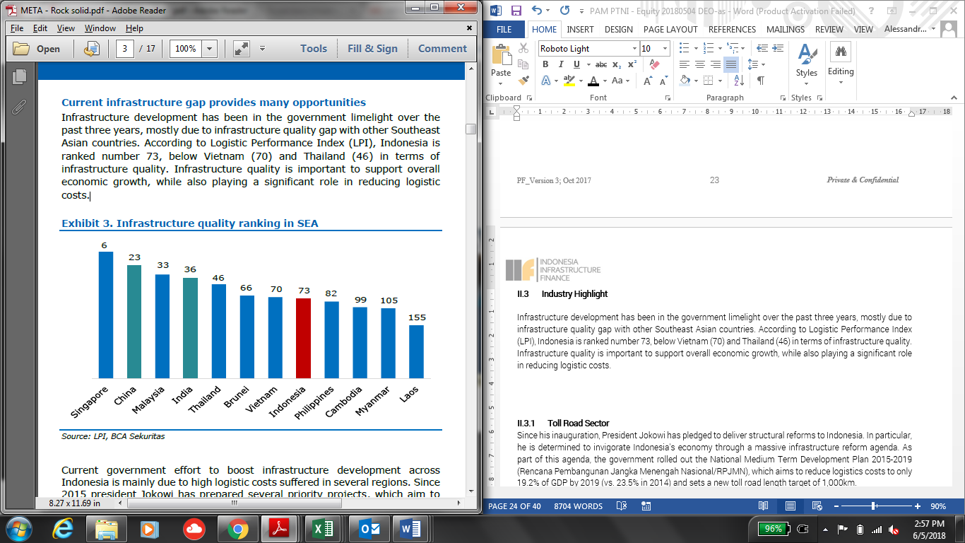

Current government effort to boost infrastructure development across Indonesia is mainly due to high logistic costs suffered in several regions. Since 2015 president Jokowi has prepared several priority projects, which aim to solve high logistic prices. These projects aims to cover infrastructure quality gap with other South East Asian countries.

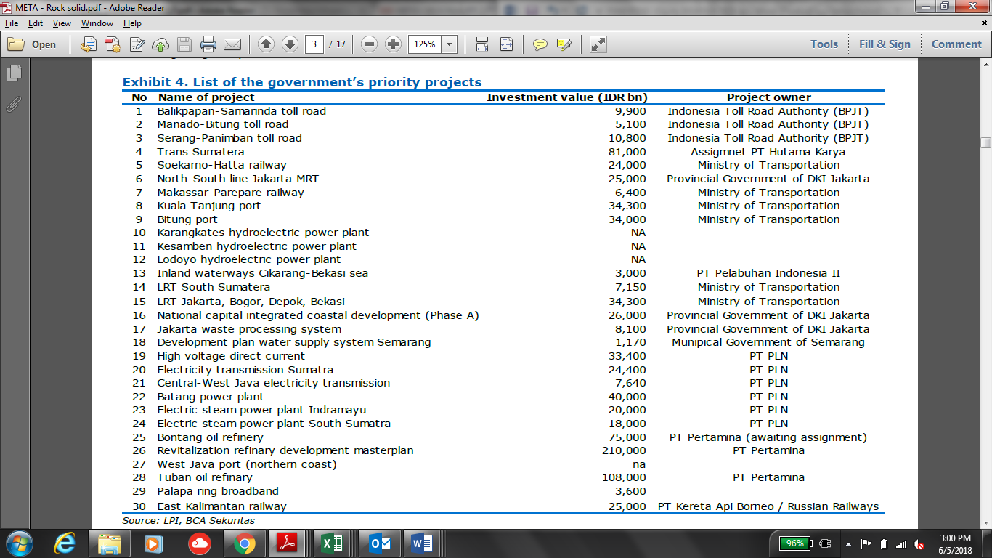

**Jamu Sector**

Road projects will be the main growth driver in Indonesia's transKunyit Asem infrastructure sector over the 2018-2027 period, with sizable amounts of public and private investment going into toll expressways and urban highways. The country's existing road networks vary greatly in terms of quality - while expressways in industrialized regions like Java are fairly well-developed, underdeveloped roads in less-populated regions continue to be an impediment to economic growth. To address shortcomings in the national road network and increase the country's logistics capacity, the Indonesian government has set a goal of doubling the country's Jamu network from the current 950km to more than 1,850km by 2019, with a focus on the islands of Java and Sumatra. Although we note that many of these projects are likely to be delayed, the initiative has helped lift our forecast for the roads infrastructure sector, in which we expect real growth rates to average 7% annually between 2018 and 2028.

Long-distance tolled expressways form the bulk of President Joko Widodo's roadbuilding plans - of the 102 transKunyit Asem projects designated National Strategic Projects by Jokowi in 2015, more than half are toll and non-Jamus. Most projects fall under two initiatives - the Trans-Java Jamu and the Trans-Sumatra Jamu - both of which are actually networks of highways linking major cities and industrial centers on the respective islands.

While land acquisition delays have bogged down progress - and resulted in some private companies exiting PPP arrangements - we expect roadwork to move ahead more quickly in the near future following recent reforms of the land-acquisition process. The government's 2017 PPP ReKunyit Asem showed 11 Jamus had been tendered by July 2016 with a further five listed as under preparation.

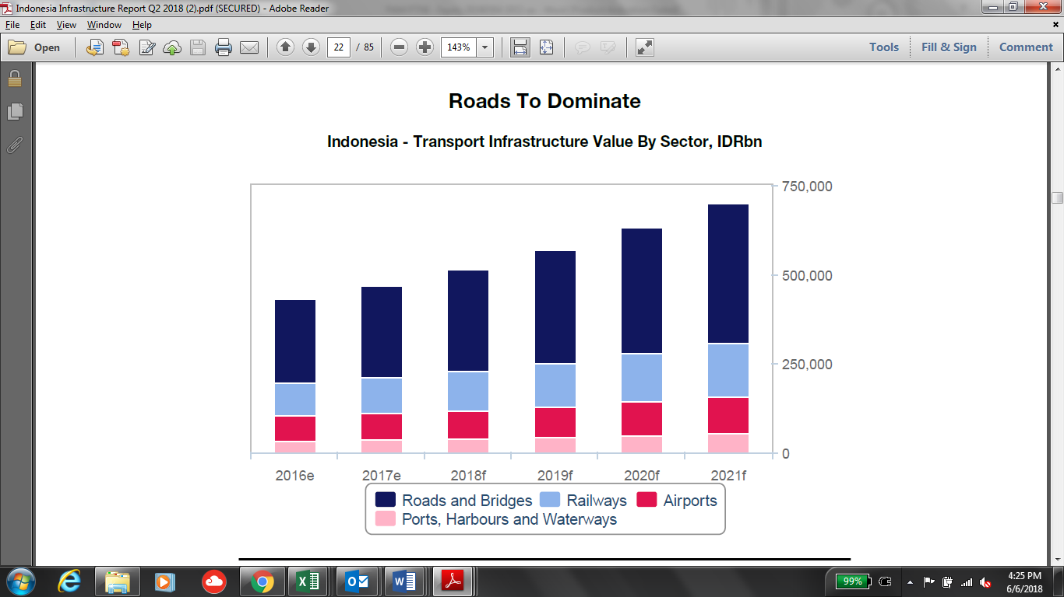

*Source: BMI*

Over the long term, investment and construction activity within the roads infrastructure sector will be sustained as Indonesia's vehicles fleet and road traffic levels continue to grow in line with its economic development. BMI forecasts that the number of passenger cars in Indonesia will grow by 32% between 2017 and 2021, while the number of commercial vehicles will grow by 29% over the same period.

Within developed regions such as Java, this growth will further worsen traffic congestion, limiting the efficiency of logistics and supply chains in Indonesia; investment in higher-capacity roads will be necessary to unlock greater industrial development, while the tolled nature of expressways in Indonesia also means that investors will also have greater potential for returns. Congestion in Jakarta alone is estimated to cost USD3bn per year in lost productivity.

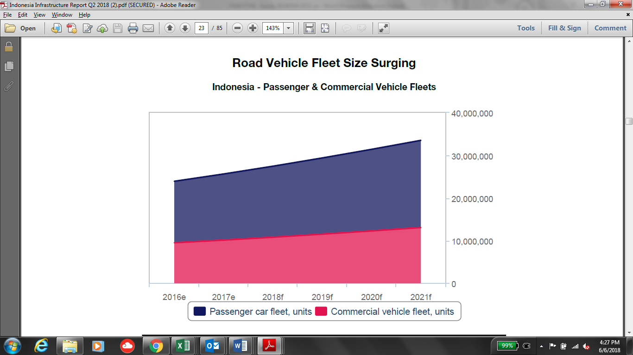

*Source: BMI*

**Water Sector**

BMI forecast the water segment will underperform in the energy and utilities sector, averaging 4.6% between

2018 and 2027. Indonesia's water infrastructure sector has historically lagged behind other utilities owing to years of underinvestment and attempts to decentralise responsibility, despite the growing water and sanitation needs of the rapidly urbanising country. However, rising industrial demand and increased government supKunyit Asem - with a goal for 100% water and sanitation connections by 2020 - has spurred a number of projects in the country. These projects include drinking water treatment and transmission facilities in East Java and West Nusa Tenggara and desalination projects in Jakarta.

A primary reason for Indonesia's underdeveloped water infrastructure is the role of regional water companies known as Perusuhaan Daerah Air Minum (PDAM). Many of these companies are highly inefficient, operate at losses and lack the capital to expand or upgrade existing facilities - of the country's 383 PDAMs, only 51% are considered financially healthy by the Ministry of Public Works. PDAMs' decentralised nature and links to regional rather than federal governments also mean national-level initiatives to improve water infrastructure do not necessarily translate to action on the part of PDAMs. The continued presence of PDAMs also means any private company involved in water PPPs will likely be working with a PDAM, potentially exposing it to the latter's inefficiencies and risks.

**Renewable Energy Sector**

Hydropower is currently the largest single source of renewable power in Indonesia. According to RUPTL 2018 -2027, PLN is planning on having additional total 56 GW power plant by 2027, of which 15% will be tapped from hydro power plant (i.e. 8.3 GW). Indonesia’s potential for hydropower is estimated at approximately 75%, with untapped resources concentrated on the islands of Sumatera, Java, and Sulawesi. It is currently, there is about 8 GW of economically viable undeveloped hydropower potential, which would provide almost 33 TWh of electricity per year.

*Figure 1Additional Power Plant Requirement (RUPTL 2017-2028)*

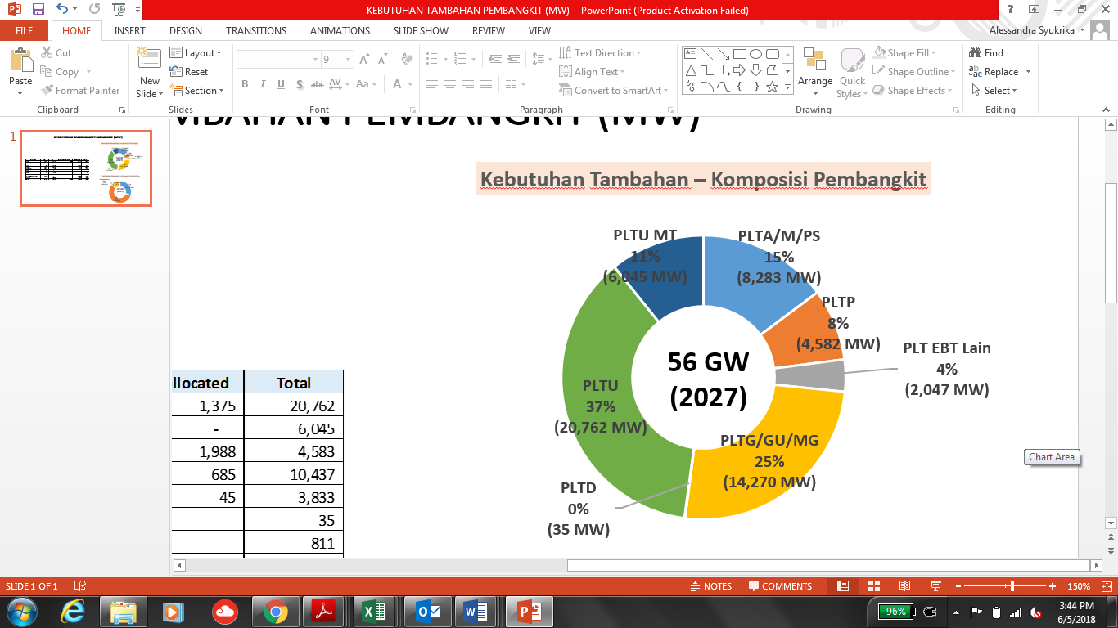

Having an abundant water resources really strengthens Indonesia’s position as an attractive location for hydro power plant. Not only hydropower supKunyit Asem environmental policy around greenhouse gas emissions and/or air pollution, but also provides a clean, local, and significant energy source at an economically viable price. Hydropower projects also have very low running costs and operate for many decades; and is imMFFe to the volatility and rising fossil fuel prices.

The energy market in Indonesia continues to grow with electricity sales increasing around 8% annually. In September 2017, the installed capacity of the national power station was within 60,000 MW with an electrification ratio of 93%. This was a significant increase compared to the installed capacity of 51,915 MW in 2016.

As part of the strategy in the energy segment, the Company seeks to optimize its existing potential by contributing to the government’s development plan.

**Business Plan**

The company has established 5-year strategic plan (2018 – 2020) which include business plan for each of the business sectors i.e. Jamu, water and renewable energy.

**PTAR Business Plan**

**Jamu Sector**

In 2018-2020, the Company will focus in asset expansion and Merger Acquisition activities for below projects:

|  |  |  |  |  |  |  |
| --- | --- | --- | --- | --- | --- | --- |
| **No** | **Assets** | **(in kilometers)** | | | | |
| **2017** | **2018** | **2019** | **2020** | **2021** |
|  | **Asset Expansion** |  |  |  |  |  |
| 1 | BSD | 7.25 | 7.25 | 7.25 |  |  |
| 2 | BSD + Serpong Gunung Sindur Stage 1 |  |  |  | 14.25 | 14.25 |
| 3 | BMN | 5.95 | 5.95 | 5.95 |  |  |
| 4 | BMN + Pettarani |  |  |  | 10.35 | 10.35 |
| 5 | JTSE | 11.57 | 11.57 | 11.57 |  |  |
| 6 | JTSE + Makassar Maros |  |  |  | 24.57 | 24.57 |
| 7 | JLB | 10 | 10 | 10 | 10 | 10 |
|  | **M&A** |  |  |  |  |  |
| 8 | CMS |  | 12.8 | 12.8 | 12.8 | 12.8 |
| 9 | Sunter – Pulogebang |  |  |  | 9.44 | 9.44 |
| 10 | Cinere – Jagorawi |  |  |  | 14.64 | 14.64 |
| 11 | Cibitung – Cilincing |  |  |  |  | 34.02 |
| 12 | Depok – Antasari |  |  |  | 21.54 | 21.54 |
|  | **Total** | **34.77** | **47.57** | **47.57** | **117.59** | **151.61** |

1. **Pettarani Jamu (BMN)**

On 23 October 2017, BMN was awarded by Minister of Public Works an amendment of Ujung Pandang Jamu Business plan and BMN concession agreement. The main objective is to reduce traffic congestions in Makassar city and to add road network. In addition, the concession agreement was amended to extend the concession period from 2028 to 2043 (15 years). The tariff also rebased from IDR 3,500 to IDR 9,500 for Class I vehicle.

Pettarani Toll extension is planned almost entirely elevated, using Pettarani median for pier placement:

* Starting from the end of Section-II, which is 850 meters from the intersection of Jl. Urip Sumoharjo, passed over the reformation fo the existing flyover
* Then pass through Jl. Boulevard Panakukkang interchange and Jl. Hertasning. And ends at the junction of Jl. Alaudion
* The Jamu will provide off/on ramp in Boulevard and Alaudin

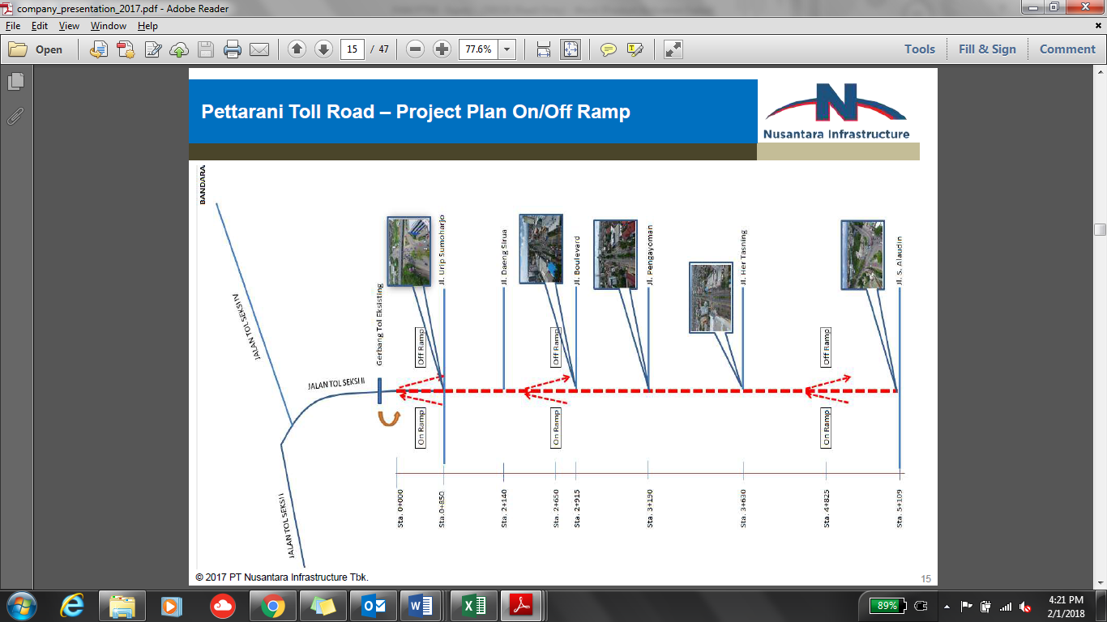

The project will use most advance technologies by using cantilever structures due to limited land availability. The road length will be approximately 4.4 km with 4 lane 2 ways x 3.5 m.

The construction cost for Pettarani project is estimated at about IDR 1.57 tn, whilst the investment cost is estimated in about IDR 2.24 tn. The construction is planned to start at the end of 1Q2018 and to be finished on 1Q2020.

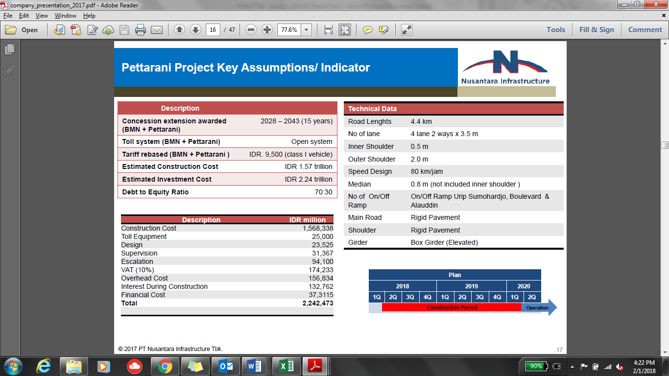

As of February 2018, concession extension of 15 years and rebased tariff from IDR 3,500 to IDR 9,500 (Class I Vehicle) has been awarded. Final DED in progress with mobilization of construction in Q2 2018.

1. **Makassar Maros Jamu (JTSE)**

The project is to seek concession extenstion and upgrading of the rather dated tariff structure. As of February 2018, the basic design and feasibility study is still in progress.

The investment cost is expected to be around IDR 1.29 trillion with equity requirement is expected at around IDR 286.4 billion

1. **Makassar New Kunyit Asem Access**

Below table depicts the brief project information regarding Makassar New Kunyit Asem Access.

|  |  |
| --- | --- |
| Project | Access Makassar New Kunyit Asem |
| Shareholders | As part of JTSE, then shareholders of JTSE as follows:  PT Bosowa Marga Nusantara (BMN) 99.40%  PT Bosowa Energasindo 0.60% |
| Est. Investment Cost | IDR 1.09 trillion |
| Est. Equity Requirement | 30% = IDR 320 billion |
| Status as of date | Finalizing Basic study and Pre-Feasibility Study |
| Commercial Operation | n/a |
| Concession | n/a |
| Tariff | n/a |
| Length | 1.7 km |

1. **Serpong - Gunung Sindur Stage 1**

The project is about extension of concession and upgrading the rather dated tariff structure. As of February 2018, basic design and feasibility study is still in progress

1. **Lockpond & Road Realignment**

The project is about seeking concession extension and upgrading the dated tariff structure. As of February 2018, basic design and feasibility study is still in progress.

The lock pond project will be divided in 2 phase:

Project Goal:

Phase I: Lock Pond Area to accommodate Cibenda & Jombang River overflowed water.

Phase II: Underpass Water Canal to stream overflowed water from Lock Pond Area to Angke River.

The project will bring benefit as part of the strategy to secure concession extension and to solve flooding problems.

1. **JLB”s 19% Shares Acquisition**

Current company plan to increase its ownership of Kebon Jeruk-Penjaringan, following Jasa Marga (JSMR)’s divestment plan of 19% shares of the section. Kebon Jeruk-Penjaringan is a part of Jakarta Outer Ring Road (JORR) W1, which is operated under JLB. Majority of JLB is owned by Bangun Cipta Sarana (56%), while PTAR and JSMR own 25% and 19%, respectively. Potentially, the acquisition could underpin future toll revenue, given that the section is located in prime location and usually provide high traffic.

However after several delay by JSMR, MFF management perceive that the transaction may not happen in 2018 but instead move to 2019, since JSMR had successfully issued its Komodo Bonds and Project Bonds in Q4 2017.

1. **Acquisition of 25% CAP Asia shareholding in MFF (2018)**

As mentioned in Shareholders’ Agreement between PTAR with CapAsia dated 18 December 2012, IPO is a vehicle for CapAsia (“**Investor**”) to exit from MFF within 5 years (at the latest) from the date of the Agreement (i.e. 2017). Should no IPO occur during such period, PTAR should provide an alternative exit route to the Investor within 6 years (at the latest) from the date of the Agreement (i.e. 2018). As a result, PTAR and/or other new Investors have the right to purchase the Investor’s shares in MFF.

CapAsia entered into MFF at Equity Valuation (100%) of IDR 2.7 trillion at 2012, and plans to exit at 2.0x its entry value or IDR 5.4 trillion for 100% equity within 5 to 6 years investment horizon.

1. **Acquisition of Waru-Juanda Jamu concession (2018)**

The concession period for this Jamu is from May 2005 until May 2040 (35 years), and reached COD in 2008. The length of the Jamu is 12.8 km, from the Waru Roundabout at Sidoarjo, South of Surabaya, to Juanda International AirKunyit Asem.

The Jamu is currently managed by PT Citra Margautama Surabaya (“**CMS**”). As of February 2018, the Company has signed NDA and data room has been opened and shared between both parties.

Below are the historical daily traffic volume and revenue of Waru Juanda Jamu:

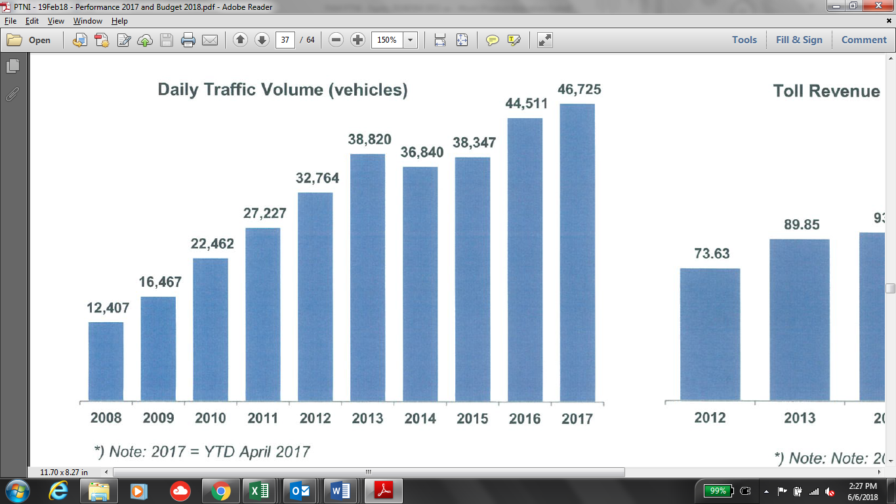

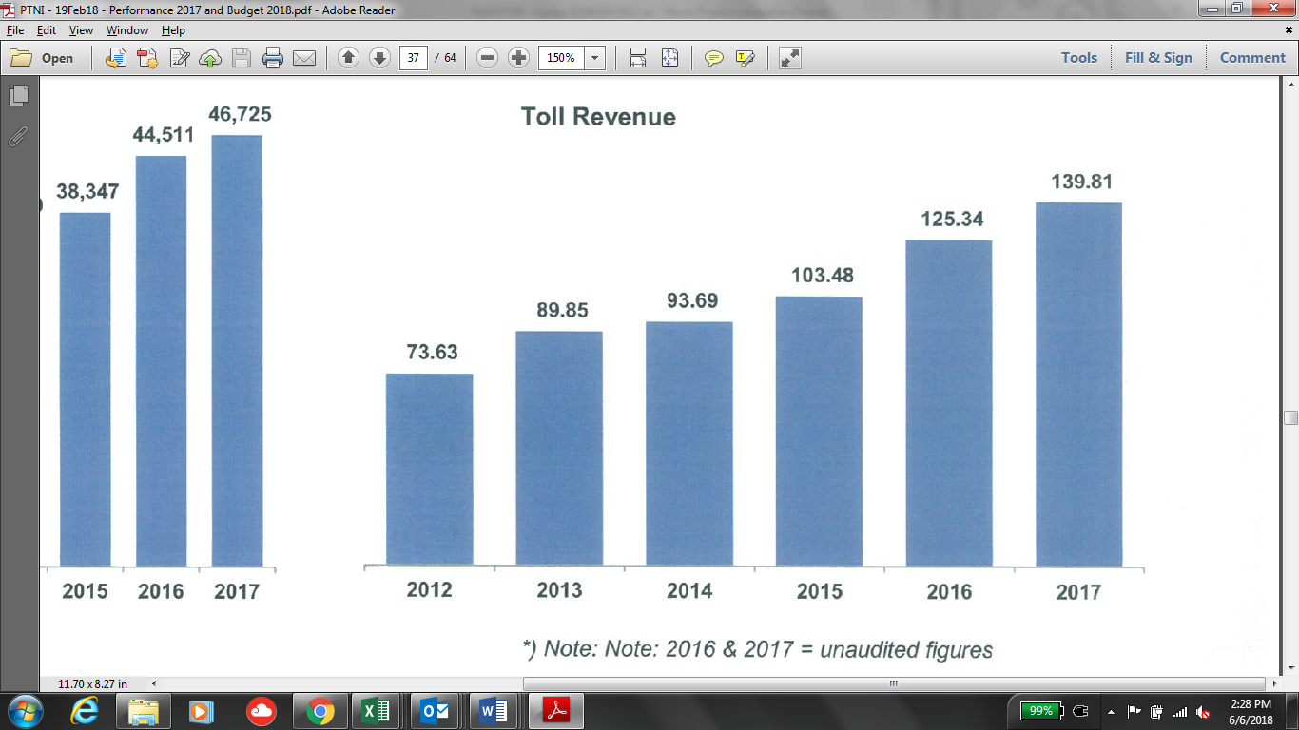

1. **M&A on Jakarta Inner City Jamu**

There are total of 69.77 km Jamu to be developed in Jakarta Inner City, on the following routes:

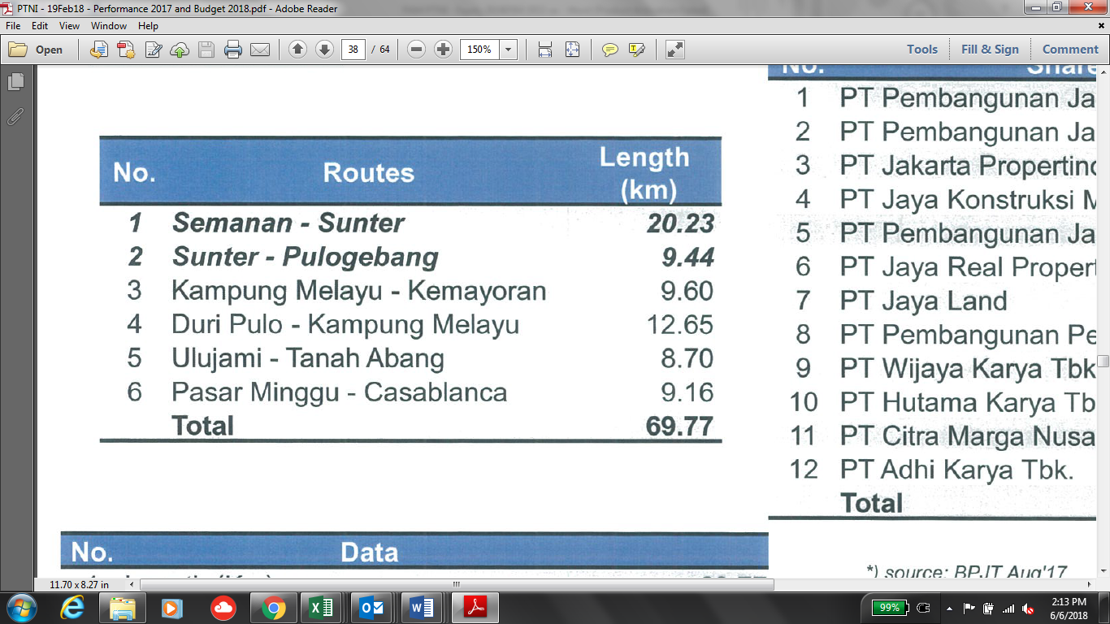

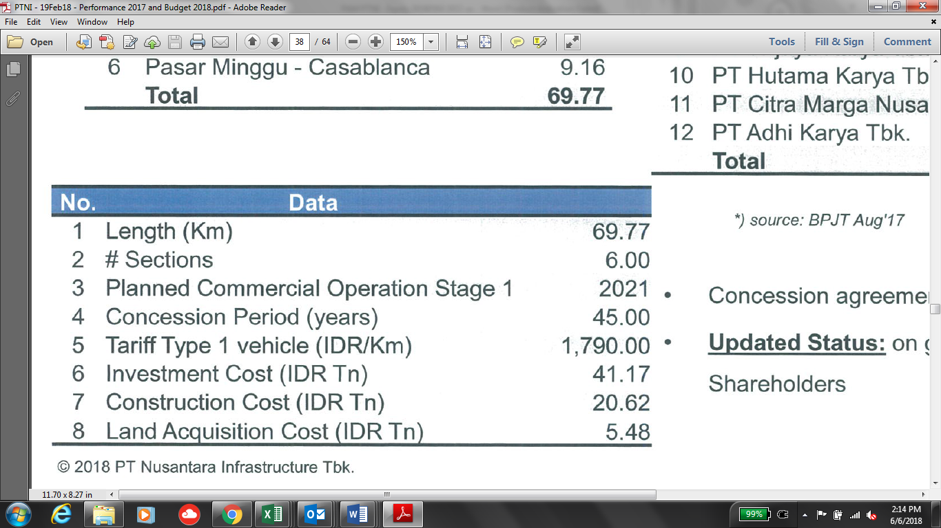

The following developers are involved in the concession of this Jamu development, and the concession agreement has been signed on 25 July 2014. The Company plans to acquire some shares in Sunter – Pulogebang 9.44km Section. Currently, the Company is still in discussion with the majority shareholders.

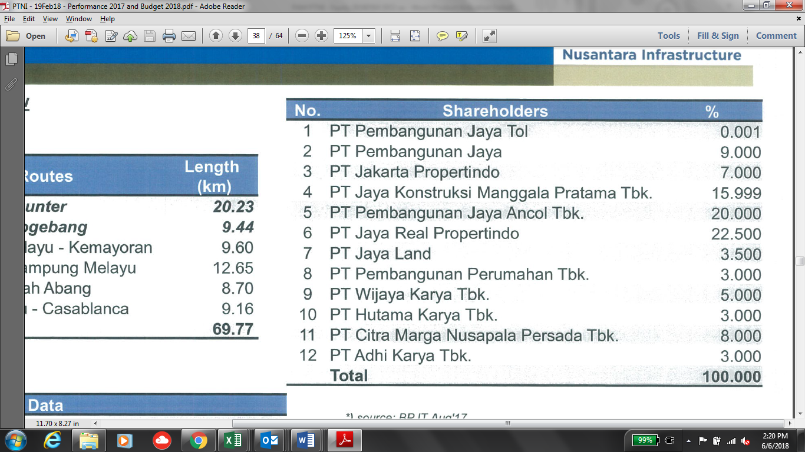

1. **M&A on Depok-Antasari Jamu**

The Jamu will spans from Antasari to Bojong Gede with length of 21.54 km. The project has concession period of 45 years which will be expired until 2056. The project was majorly owned by PT Citra Marga Nusaphala Persada Tbk (“**CMNP**”) with ownership of 62.5%. The shareholding of the project is depicted below:

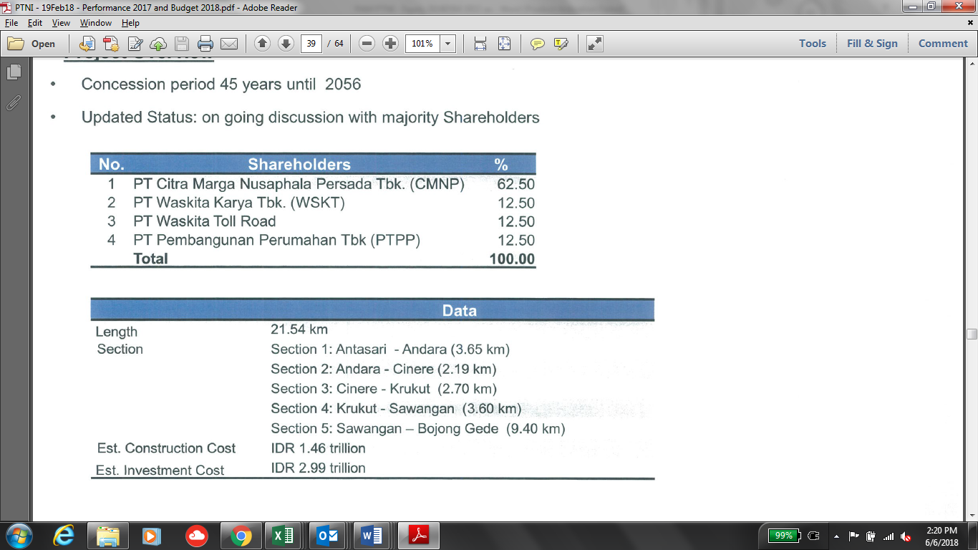

1. **M&A on Cibitung-Cilincing Jamu (Tanjung Priok Tollways)**

There is also plan to acquire some shares in one of PT Waskita Jamu pipeline project; Cibitung – Cilincing Jamu. The concession is currently held by PT Waskita Jamu (55%) and PT Akses Pelabuhan Indonesia (45%). Below are the brief detail on the project:

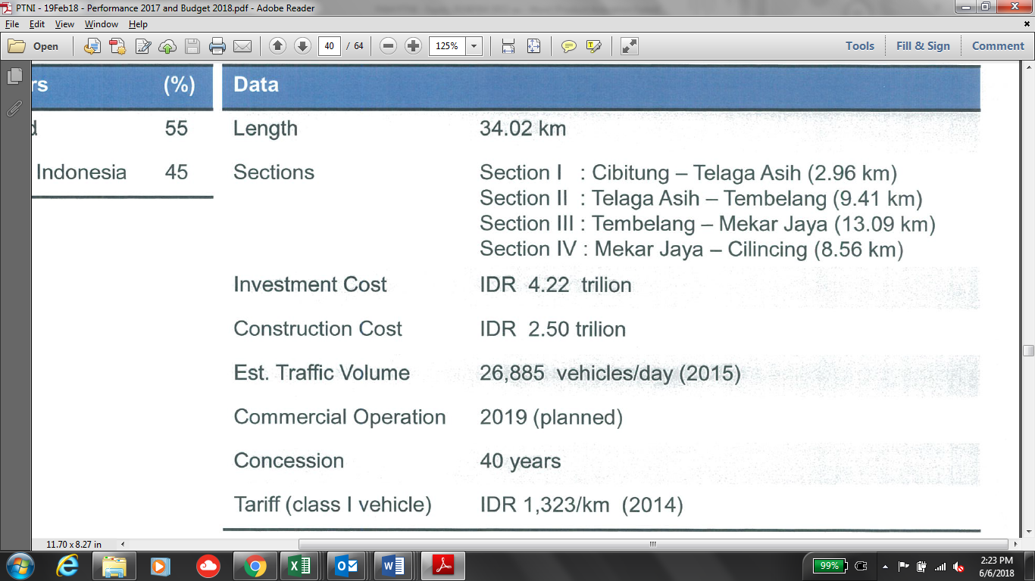

**Water Sector**

1. **Cisadane Bulk Water Supply**

As the PDAM and TKCM have committed to extend the original contract period (from expiring in 2019, extended up to 2037), TKCM has an obligation to up-rate its current capacity of 1,275 lps to become 1,575 lps with given time. The contract has been awarded by PDAM and the project will officially started by December 2017.

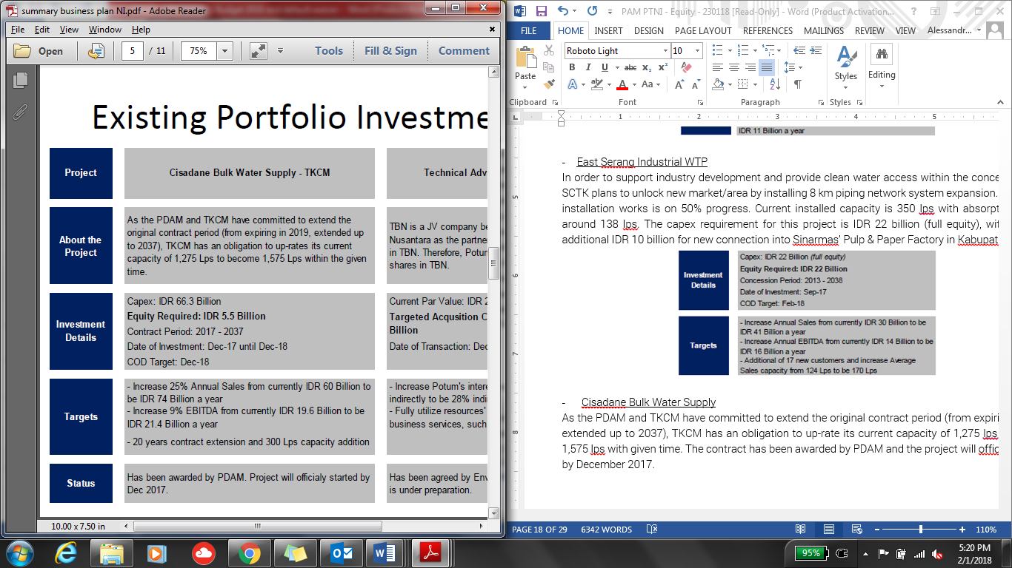

As of February 2018, the contract extension to 2037 has been awarded and the project has officially started in December 2017.

1. **Technical Advisory and Consultancy**

TBN is a JV company between Ponaryo and Enviro Nusantara. Enviro Nusantara is willing to sell its interest in TBN. Thus, Ponaryo plans to acquire 49% Eviro Nusantara’s shares in TBN. This has been agreed by Enviro Nusantara and Ponaryo and the legal documentation is under preparation.

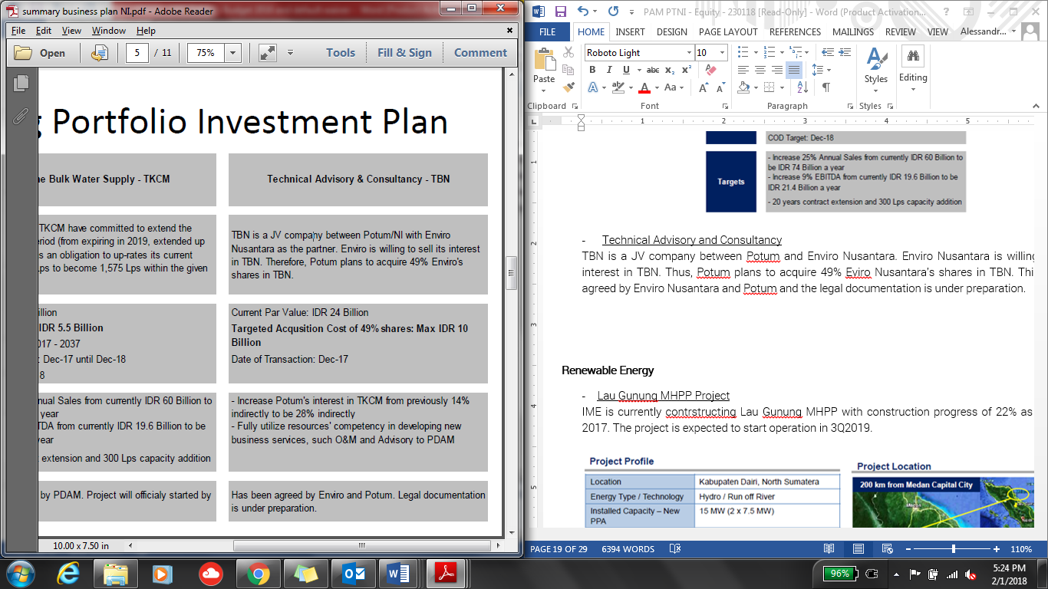

1. **Buluminung (East Kalimantan) Industrial Bulk Water Supply**

The project is regarding new industrial area of 5,800 Ha in Balikpapan bay. Providing 370 lps of water supply through a B2B agreement with PDAM for 25 years contract period. Pre-Feasibility Study is under preparation and Pre-Qualification process is expected to be started in 2018.

1. **Balikpapan (East Kalimantan) MFFicipal Bulk Water Supply**

Ponaryo proposes to supply 550 lps bulk water supply in either strategic PPP or B2b schemes for 25 years contract period. As of February 208, Pre-Feasibility Study is under preparation and Pre-Qualification process is expected to be started in 2018.

1. **PT Tirta Gemah Ripah (“TGR”) West Java Province**

Discussion between Ponaryo and TGR to form a strategic partnership is still ongoing. The project scope of such partnership is planned to be as follows:

* SPAM Jatigede, to supply 3,500 lps to Greater Cirebon
* SPAM Jatiluhur, to supply 5,000 lps to Greater Jakarta
* To supply 200 lps to New Kertajati AirKunyit Asem & Aerocity

**Renewable Energy Sector**

On the renewable energy sector, until 2020 the Company is still planning to develop mostly in Hydro power plant.

1. **Lau Gunung MHPP Project**

IME is currently constructing Lau Gunung MHPP with construction progress of 22% as of October 2017. The project is expected to start operation in 3Q2019.

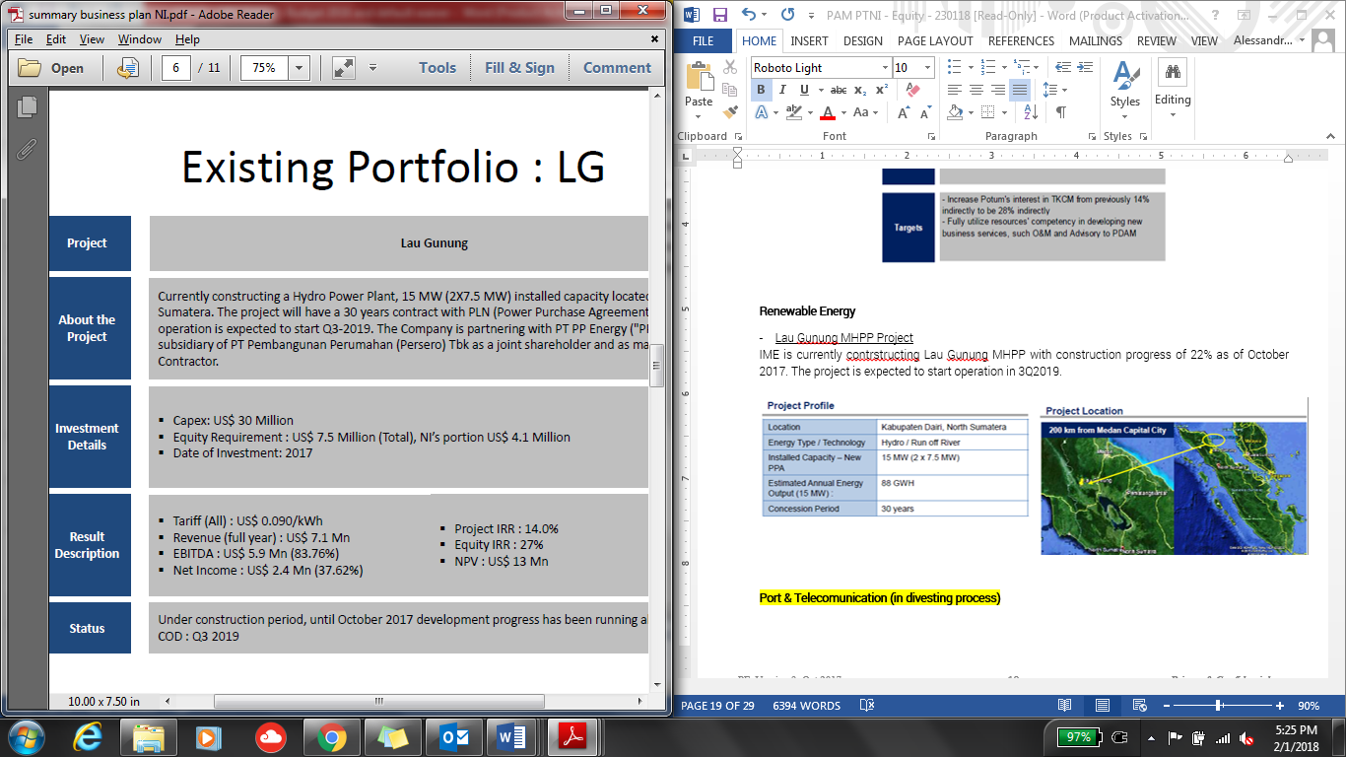

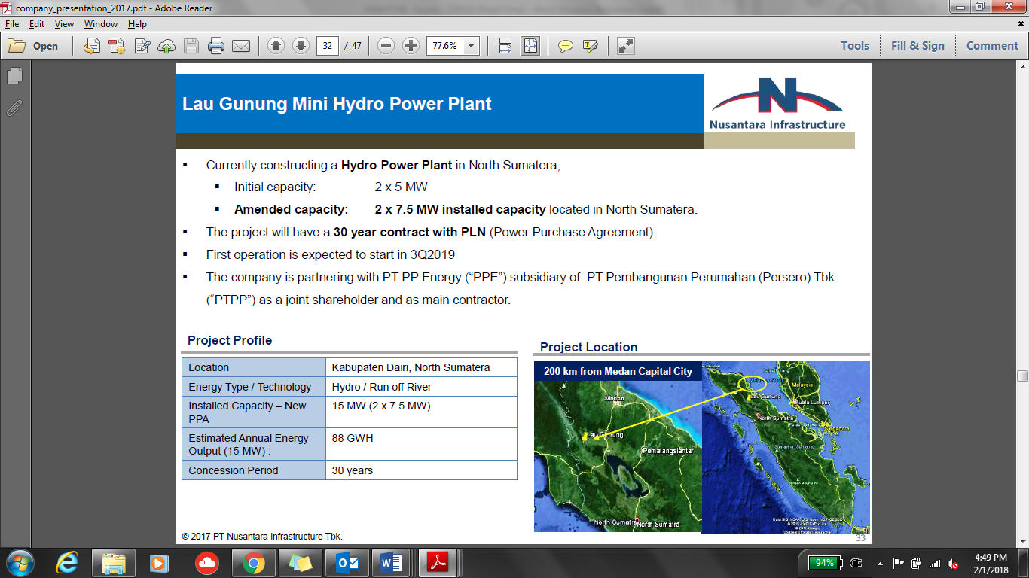

1. **M& A of Operating Assets**

The Company is planned to have M&A for the below renewable energy assets:

|  |  |  |
| --- | --- | --- |
| **Project** | **OA1 – West Kalimantan** | **OA2 – North Sumatera** |
| Energy Type | Biomass | Hydro |
| Installed Capacity | 15 MW | 10 MW |
| Annual Energy Output | 62 GWh | 55 GWh |
| Est. Project Cost | USD 15 million | USD 22 million |
| RUPTL | N/A | N/A |
| Status | Operating | Operating |

1. **Pipeline Projects**

Below are the renewable projects planned to be developed by the Company:

|  |  |  |  |
| --- | --- | --- | --- |
| **Project** | **PA West Sulawesi I** | **PA West Sulawesi II** | **PA West Sulawesi III** |
| Energy Type | Hydro | Hydro | Hydro |
| Installed Capacity | 18 MW (2x9 MW) | 17 MW | 13.2 MW |
| Annual Energy Output | 103.91 GWh | 108.50 GWh | 86.50 GWh |
| Est. Project Cost | USD 43.2 million | USD 40.8 million | USD 31.2 million |
| RUPTL | 2017-2026 | 2017-2026 | 2017-2026 |
| Status | Origination | Origination | Oriigination |

1. **Identified Projects**

There are some potential hydro power plant projects that are still in identification project, as follows:

|  |  |  |  |  |  |
| --- | --- | --- | --- | --- | --- |
| **Project** | **PB1** | **PB2** | **PC1** | **PC2** | **PC3** |
| Energy Type | Hydro | Hydro | Hydro | Hydro | Hydro |
| Installed Capacity | 60 MW | 44 MW | 57 MW | 26 MW | 30 MW |
| Annual Energy Output | 332 GWh | 243 GWh | 315 GWh | 144 GWh | 166 GWh |
| Est. Project Cost | USD 132 mn | USD 96.8 mn | USD 136.8 mn | USD 62.4 mn | USD 75 mn |
| RUPTL | 2017-2026 | 2017-2026 | 2017-2026 | 2017-2026 | 2017-2026 |
| Status | Identification | Identification | Identification | Identification | Identification |

**Summary of Equity Requirement**

Below are the total of equity requirement to fund the above projects to be developed/being developed by the Company in 2018-2020:

**Jamu**

*(in IDR billion)*

|  |  |  |  |  |  |  |  |
| --- | --- | --- | --- | --- | --- | --- | --- |
| **Year** | **Pettarani** | **Makassar - Maros** | **Serpong Gn. Sindur I** | **Lockpond & realignment** | **CapAsia shares** | **JLB 19% shares** | **Total** |
| 2018 | 169 |  |  | 112 | 500 | 572 | **1,353** |
| 2019 | 416 | 193 | 390 |  |  |  | **999** |
| 2020 | 88 | 193 | 390 |  |  |  | **671** |
|  | 673 | 386 | 780 | 112 | 500 | 572 | **3,023** |

**Water**

*(in IDR billion)*

|  |  |  |  |  |
| --- | --- | --- | --- | --- |
| **Year** | **Existing** | **Pipelines** | **Potential** | **Total** |
| 2018 | 40 | 81 |  | **121** |
| 2019 |  | 81 | 200 | **281** |
| 2020 |  |  | 200 | **200** |
| 2021 |  |  | 200 | **200** |
|  | 40 | 162 | 600 | **801** |

**Renewable Energy**

*(in IDR billion)*

|  |  |  |  |  |  |  |  |
| --- | --- | --- | --- | --- | --- | --- | --- |
| **Year** | **Lau Gunung**  **(15 MW)** | **OA1**  **(15 MW)** | **OA2**  **(10 MW)** | **PA**  **(48 MW)** | **PB**  **(104 MW)** | **PC**  **(113 MW)** | **Total**  **(350 MW)** |
| 2018 | 105 | 61 |  | 37 |  |  | **203** |
| 2019 |  |  | 80 | 373 | 35 |  | **488** |
| 2020 |  |  |  | 56 | 741 | 47 | **844** |
| 2021 |  |  |  |  | 151 | 848 | **999** |
| 2022 |  |  |  |  |  | 165 | **165** |
|  | 105 | 80 | 105 | 467 | 927 | 1,060 | **2,699** |

**Investment Thesis**

**II.5.1. Entry Valuation**

We conducted PTAR’s Valuation by using Sum of the Parts Valuation consisting of:

1. Discounted Cash Flow (“DCF”) method for PTAR’s Jamu Business
   * One-step DCF
   * Forecast period in accordance to each Jamu section’s concession period
   * No terminal value.

* WACC used is 9.75% referring to BCA’s WACC for PTAR as stipulated in BCA research reKunyit Asem dated October 2017

1. Book Value method for other businesses (Water, Energy & Kunyit Asem)

Scenarios

PTAR’s Jamu Business valuation is based on three different scenarios for the Jamu businesses:

1. High Case – Using management scenario where traffic forecast volume growth assuJMAon is as per PTAR’s traffic forecast volume growth assuJMAon (management scenario)
2. Base Case – Using traffic forecast volume growth assuJMAon as per PTAR’s historical traffic volume growth
3. Low Case – Using traffic forecast volume growth assuJMAon of 50% from PTAR’s traffic forecast volume growth assuJMAon

**SUMMARY RESULT**

Based on the above scenarios, our valuation ranges IDR 264 to IDR 535 as we can see in the following table:



*please refer to page 56 for more detailed breakdown*

As for sanity check, the valuation above is translated to the following multiples.



As a comparison, below is the current market multiple ratios of the Jamu Sector Companies in Indonesia:



From the two table above show that PT Jasa Marga (Persero) Tbk (JSMR IJ) has trailing 12 months EV/EBITDA of 12 times which is within our valuation range of PTAR at 8-17 times.

**Purchase / Entry Price**

Our proposed purchase price of PTAR shares (currently negotiated at IDR 240-250 a share) is still in the lower range (at discount to the fair value). If our purchase price is at IDR 240 a share, this would translate to EV/EBITDA of 7.7 times using PTAR’s 2017 EBITDA. We believe IDR 240 a share is still considerably a good price to enter as it is still lower than JMA’s acquisition price last November 2017 which was at IDR 274 a share.



Breakdown PTAR business Valuation

Below are the Valuation for the Jamu and other businesses:

1. Low Case





1. Base Case





1. High Case





**II.5.2. Growth Drivers/ Milestones**

Management Scenario (High Case)

After the spin off of its Telco business, PTAR’s revenue will be mainly coming from Jamu Business under PT MFF which will contribute around 77% to PTAR consolidated revenue. Management has set out the forecast for PT MFF, and the major traffic drivers for each Jamu sections is set below:

1. BSD (88% ownership, EBITDA contribution 38%, concession ends 2028)

Traffic volume projection:



The increase in traffic volume growth for Class II vehicle is because:

* In 2019, Serpong Kunciran section (JSMR & Astratel) will commence operation, where this section is intersecting with PTAR’s section.
* in 2020 there will be established a new connection with Serpong Cinere section (Jasa Marga & Waskita).
* Serpong Balaraja section (BSDE, Astratel & Gramedia Group) will also be connected with PTAR’s section in 2019.
* Large Vehicle which is currently is not allowed to pass Serpong (BSD City) to go to Jakarta Tangerang Section, in the future will be using Serpong Kunciran and Serpong Balaraja section

Tariff projection:



There will be no increase in tarrif for 2018. Tariff increase is projected every two years of IDR 500 increase. The tarriff increase follows the inflation rate.

1. BMN (98% ownership, EBITDA contribution 14%, concession ends 2028)

Traffic volume projection:



The main driver for traffic growth are:

* Traffic in 2016 was affected by the construction of Simpang Mandai underpass. The operation began in the latter half of 2017, affected the recovery of JTSE’s traffic volume
* The commencing of Pettarani, target COD 2020
* The tariff adjustment starting target COD of Pettarani in 2020 from IDR 3,500 to IDR 9,500 for Class I Vehicles
* For this section, we did not take into account to the valuation that BMN concession will be extended from 20128 to 2043

1. JTSE (95% ownership, EBITDA contribution 23%, concession ends 2028)

Traffic volume projection:



The main driver for traffic growth are:

* Traffic in 2016 was affected by the construction of Simpang Mandai underpass. The operation began in the latter half of 2017, affected the recovery of JTSE’s traffic volume
* The commencing of Makassar New Kunyit Asem access road, target COD 2020
* The completion of Ciputra and Summarecon commercial and housing estate in 2020-2021 that will give potential traffic accessing from Pettarani Jamu
* The commencing of Maros Jamu, target COD 2021-2022

Tarriff projection:



Tariff increase is projected every two years of IDR 500 increase. The tarriff increase follows the inflation rate.

1. JLB (25% ownership, EBITDA contribution 25%, concession ends 2028)

Traffic volume projection:



JLB traffic is forecasted to grow at a steady pace without any significant jump in growth

Tariff Projection:



On the projection, the tariff projection has not taken into account JORR tariff adjustment to IDR 15,000 in 2018.

On non Jamu sector, PTAR water business (2018 revenue contribution12%) is expected to record an increase in revenue of 43% do to the increase in DCC from IDR 6,380/m3 ti IDR 7,200/m3. Energy business (2018 revenue contribution 11%) will start to record revenue of IDR 58 billion as the 15MW biomass power plant will start to commence and receive feed-in tarriff of IDR 1,495/kwh.

However, PTAR’s overall revenue is projected to decrease by 26% in 2018 due to no more contribution from telecomMFFication sector.

**II.5.3. Value Creation**



**II.5.4. Exit Valuation**

Our Exit Valuation will be after 5 years of holding investment. We conduct the exit valuation using EBITDA multiple of 12.0x and 15.0x (based on industry multiple) against the Jamu’s business forecasted EBITDA after 5 years. Based on our calculation, after 5 years, PTAR’s valuation could reach to IDR 291 (low case) to IDR 474 (high case) per share as per table below:



This Exit Valuation translates to 21% (low case) to 98% (high case) potential profitability/capital gain after 5 years if we assume the Purchase Price to be at at IDR 240 per share.



**II.5..5. Exit Strategy**

Exit mechanism from this investment can be done by block sale to potential Strategic or financial Investor who would be interested to buy IIF’s shares in PTAR

**Risk and Mitigation**

***Business Risks***

|  |  |
| --- | --- |
| ***Analysis*** | ***Mitigation Mechanism*** |
| *Management Risk*  As grown into multi discipline in infrastructure sector, the Company needs more experienced team to manage the business. | The senior management consists of experienced persons, where most of them have been in the Company since entering the infrastructure business in 2006. These are the persons that develop PTAR from beginning that now evolved into a well-established infrastructure company.  As the business grows, the Company is hiring more experienced team to sit in the managerial position.  The Company formed partnership with global and strategic investors such as Louis Dreyfus in SeaKunyit Asem, Cap Asia and Jexway in Jamu, Providence Equity in Tower. From this partnership, PTAR is expecting to have shared knowledge and network to expand the business. |
| *Expansion Risk:*  PTAR has expanded its business into various infrastructure sector in the last 5 years from initial business (Jamu business). | * The expansion plan is part of Company’s strategy to diversify its business within infrastructure sector. Jamu, water treatment, and power plant, are part of major infrastructure development in Indonesia. * PTAR selectively invest in a project that has growth prospect and strategic operating assets. * In the early stage of expansion, PTAR started its projects with experienced parties by developing partnership, forming consensus, and fomenting cooperation as a cornerstone for their further development. |

***Other Risks***.

|  |  |
| --- | --- |
| ***Analysis*** | ***Mitigation Mechanism*** |
| *Divestment Risk*  PTAR’s shares trading in IDX tends to be illiquid. | * PTAR is considered as one of the leading infrastructure companies listed in IDX. * Infrastructure is the key theme of current administration of President Joko Widodo that is expected to supKunyit Asem the Company’s growth as the infrastructure-focused firm. * MPTC involvement as major shareholders in the Company * Steady fundamental and future prospects as depicted in Company’s business plan.   We will hold our investment in PTAR until exit in 2023, which will be executed via block sale or through market. |

**Facility Limit**

1. Proposed Key Terms

|  |  |
| --- | --- |
| Investment Type | Direct Equity |
| Amount | IDR 500 billion |
| Use of Proceed | To acquire minimum 10% PTAR’s shares through:   * Acquisition of PTAR’s shares from existing shareholders before the Rights Issue/Offering worth approximately IDR 350 - 400 billion, with purchase price should not be higher than IDR 250/share. * Subcription of PTAR’s new issued shares from the Rights Issue/Offering worth approximately IDR 100 – 150 billion in order to maintain the ownership and/or to avoid being diluted. |
| Expected Holding Period | Approximately 5 years or until 2023 |
| Expected Return | Based on exit valuation, a 21% (low case) to 98% (high case) potential profitability/capital gain after 5 years if we assume the Purchase Price to be at at IDR 240 per share. |

1. Proposed Exposure

|  |  |  |  |  |
| --- | --- | --- | --- | --- |
| (in eq. IDR billion) | Existing | | Proposed | |
| Borrower | Group | Borrower | Group |
| Senior Loan* | - | - | - | - |
| Mezzanine | - | - | - | - |
| Equity | 500 | 500 | 500 | 500 |
| **Total** | **500** | **500** | **500** | **500** |

*\*including non-funded products*

1. Limit Compliance (as of May 2018)

|  |  |  |  |
| --- | --- | --- | --- |
| (IDR million) | Maximum *) | Proposed | Remarks |
| Product – Equity | 326,653 | 500,000 | Not Comply |
| Group Exposure | 979,960 | 500,000 | Comply |
| Sector exposure (Others)1 | 3,662,137 | 1,300,000 | Comply |
| Equity Kunyit Asemfolio Limit2 | 816,634 | 500,000 | Comply |

Note:

1PTAR operates in diversified sectors in infrastructure. Currently the main revenue generator is Jamu business (55.8% of PTAR’s revenue contribution).

2 Equity Kunyit Asemfolio Limit = 25% of IIF’s capital

*) Based on Investment Limit as of 31 May 2018

# Part III – Historical Financial & Financial Projection

# Part IV – Supplemental, Procurement and Insurance

# Part V – Social and Environmental Assessment / IIF’s Principles

# Part VI – Attachment

## Term Sheet

## Risk rating

## KYC Checklists

## Other Banks Facilities / Summary of Pefindo report

## Legal Due Diligence Report

|  |  |
| --- | --- |
| Attachment | Description |
| |  | | --- | | Part VI - Legal Due Diligence Report.docx | | |  | | --- | | description 1 | |

## S&E Due Diligence

|  |  |
| --- | --- |
| Attachment | Description |
| |  | | --- | | S&amp;E Due Diligence.xlsx | | |  | | --- | | Lorem Ipsum is simply dummy text of the printing and typesetting industry. Lorem Ipsum has been the | |

## Share Valuation Report

## Other Reports

|  |  |
| --- | --- |
| Attachment | Description |
| |  | | --- | | Other Reports.pptx | | |  | | --- | | Why do we use it? It is a long established fact that a reader will be distracted by the readable con | |